

HAPPY PROGRAMMING
Software Design Specification

– Hanoi, May 2023 –

Record of changeS
Date | A*  M, D | In charge | Change Description
15,May | A | LamNB | Add few overview
12,Jun | A,M | TuanDV | Add more code designs
26,Jun | A | LamNB | Add more code designs
*A - Added M - Modified D - Deleted

Table of Contents
I. Overview 7
1. Code Packages 7
2. Database Design 8
a. Database Schema 9
b. Table Description 9
II. Code Designs 10
1. HomePage 10
a. Class Diagram 10
b. Class Specifications 11
c. Sequence Diagram(s) 11
d. Database queries 11
2. SignUp 12
a. Class Diagram 12
b. Class Specifications 13
c. Sequence Diagram(s) 14
d. Database queries 14
3. ViewCVMentor 14
a. Class Diagram 15
b. Class Specifications 15
c. Sequence Diagram(s) 16
d. Database queries 17
4. ResetPassword 18
a. Class Diagram 18
b. Class Specifications 19
c. Sequence Diagram(s) 20
d. Database queries 20
5. UpdateUserProfile 20
a. Class Diagram 21
b. Class Specifications 21
c. Sequence Diagram(s) 22
d. Database queries 22
6. ViewAllSkill 23
a. Class Diagram 23
b. Class Specifications 23
c. Sequence Diagram(s) 24
d. Database queries 25
7.SignIn 26
a. Class Diagram 27
b. Class Specifications 28
c. Sequence Diagram(s) 29
d. Database queries 30
8. ListMentorSuggestion 31
a. Class Diagram 32
b. Class Specifications 33
c. Sequence Diagram(s) 34
d. Database queries 35
9. CreateRequestMentee 36
a. Class Diagram 37
b. Class Specifications 38
c. Sequence Diagram(s) 39
d. Database queries 40
10.ListAllMentorAndSearch 41
a. Class Diagram 42
b. Class Specifications 43
c. Sequence Diagram(s) 44
d. Database queries 45
11. ViewListOfSkills 46
a. Class Diagram 47
b. Class Specifications 48
c. Sequence Diagram(s) 49
d. Database queries 50
12. CreateCVOfMentor 51
a. Class Diagram 52
b. Class Specifications 53
c. Sequence Diagram(s) 54
d. Database queries 55
13. ViewListMentor 56
a. Class Diagram 57
b. Class Specifications 58
c. Sequence Diagram(s) 59
d. Database queries 60
14.UpdateRequest 61
a. Class Diagram 62
b. Class Specifications 63
c. Sequence Diagram(s) 64
d. Database queries 65
15.UserAuthorization 66
a. Class Diagram 67
b. Class Specifications 68
c. Sequence Diagram(s) 69
d. Database queries 70
16.Rate&CommentMentor 71
a. Class Diagram 72
b. Class Specifications 73
c. Sequence Diagram(s) 74
d. Database queries 75
17. UpdateSkill 76
a. Class Diagram 77
b. Class Specifications 78
c. Sequence Diagram(s) 79
d. Database queries 80
18. StatisticRequestByMe 81
a. Class Diagram 82
b. Class Specifications 83
c. Sequence Diagram(s) 84
d. Database queries 85
19. ViewListFollowingRequest 86
a. Class Diagram 87
b. Class Specifications 88
c. Sequence Diagram(s) 89
d. Database queries 90
20. ViewStatisticRequest 91
a. Class Diagram 92
b. Class Specifications 93
c. Sequence Diagram(s) 94
d. Database queries 95
21. ChangePassword 96
a. Class Diagram 97
b. Class Specifications 98
c. Sequence Diagram(s) 99
d. Database queries 100
22. UpdateCVOfMentor 101
a. Class Diagram 102
b. Class Specifications 103
c. Sequence Diagram(s) 104
d. Database queries 105
23. ListRequestByMe 106
a. Class Diagram 107
b. Class Specifications 108
c. Sequence Diagram(s) 109
d. Database queries 110
24. CreateSkill 111
a. Class Diagram 112
b. Class Specifications 113
c. Sequence Diagram(s) 114
d. Database queries 115
25. StatisticsOfAllMentee 116
a. Class Diagram 117
b. Class Specifications 118
c. Sequence Diagram(s) 119
d. Database queries 120

I. Overview

1. Code Packages

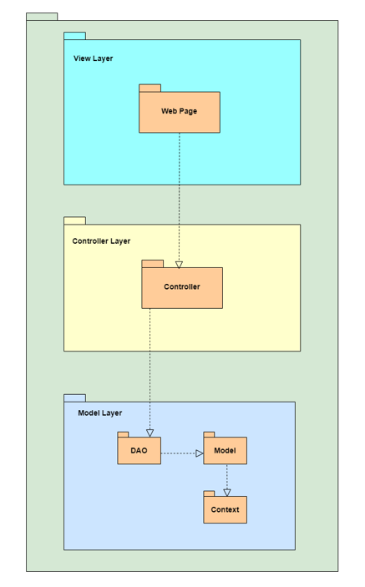
Package descriptions
No | Package | Description
01 | Web pages | Contain UI page
02 | Controller | Contain servlets to process request and response of system
03 | Dao | Contain class to process business logic of system
04 | Model | Contain objects class of system
05 | Context | Contain class to connect database

2. Database Design

a. Database Schema
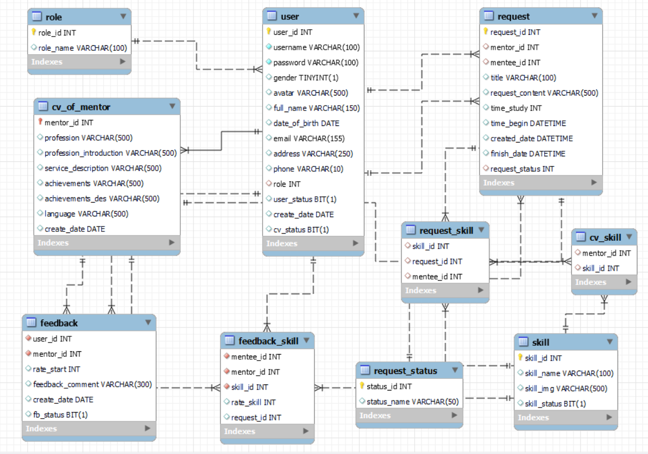

b. Table Description
No | Table | Description
01 | User | The "User" table stores information about users in the system. It serves as the primary source of user data and is essential for user authentication, authorization, and personalization features.
02 | Role | The "Role" table is responsible for storing information related to user roles within the system. User roles define the permissions and access levels granted to different user types, allowing for fine-grained control over system functionality and data.
03 | Cv_Skill | The table tempt of table CV_of_mentor and Skill
04 | Request | Create a new request to get support from Mentor.  Allow Mentee input Title (subject) of request, deadline date, deadline hour, content o f request, select skills (at least one checkbox and max is three checkboxes) the programming language(framework) the Mentee want to learn and OK button.  The request will has status: Open, Processing, Cancel, Closed
05 | Skill | Save programming skills that mentees can learn
06 | Feedback | The "feedback" table tracks the feedback of mentee for mentor.
07 | Request_Skill | The table tempt of table Request and Skill
08 | Request_Status | Show the all status of request mentee to mentor
09 | CV_Of_Mentor | Table "CV_OF_mentor" tracks information and skills about mentor
10 | Feedback_skill | Save rate star of each skill for each request from mentee to mentor

II. Code Designs

1. Home Page

a. Class Diagram
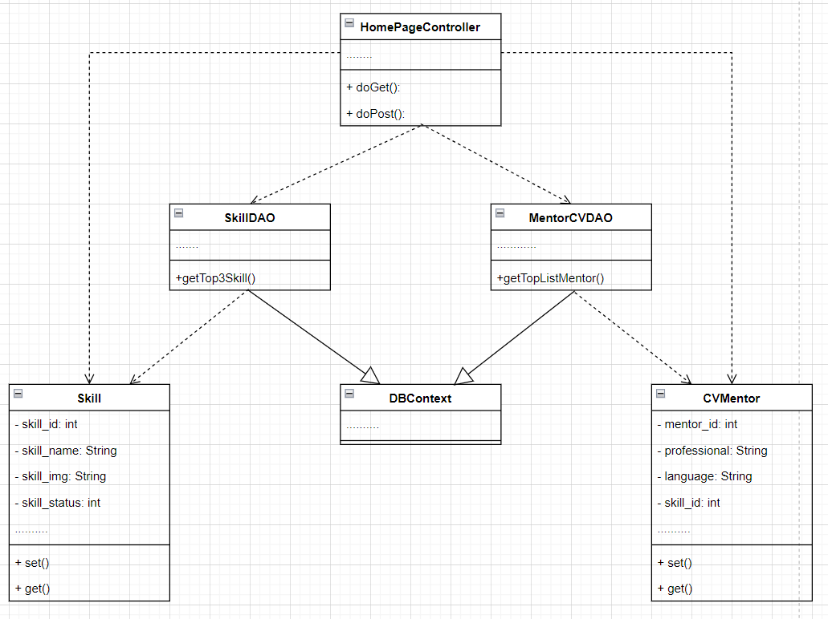

b. Class Specifications

HomePage Controller Class

No | Method | Description
01 | doGet() | The doGet method is typically used when the client wants to access a web page, get data from the server, or perform read-only operations.
02 | doPost() | The doPost method is usually used when the client wants to send data to the server, like submitting a form or performing operations that can change the data.

SkillDao Class

No | Method | Description
01 | getTop3Skill() | The getTop3Skill() method is the method to get the List that includes the 3 most connected learning skills of the system.

MentorCVDAO Class

No | Method | Description
01 | getTopListMentor() | The getTopListMentor() method is the method to retrieve the List including the 4 most connected mentors of the system.

c. Sequence Diagram(s)
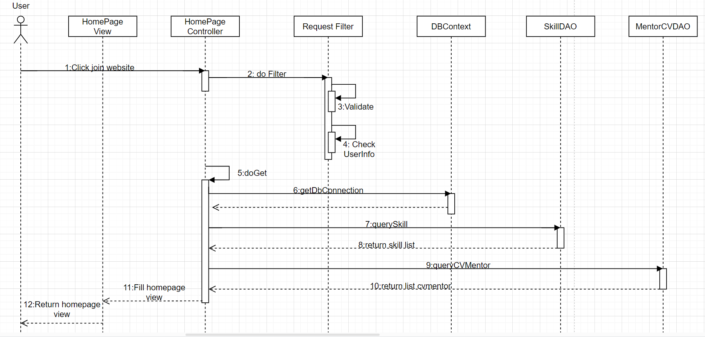

d. Database Queries
- SELECT cv.mentor_id, u.email, u. full_name, u.avatar,cv. profession, cv.profession_introduction,cv.service_description,cv. achievements, COUNT(*) AS request_count
FROM cv_of_mentor cv
INNER JOIN user u on cv.mentor_id = u.user_id
INNER JOIN request req ON cv.mentor_id = req.mentor_id
INNER JOIN request_status rs ON req.request_status = rs.status_id
WHERE rs.status_name = 'Cancel'
GROUP BY cv.mentor_id
ORDER BY request_count DESC
LIMIT 4;

- SELECT s.skill_id, s.skill_name,s.skill_img COUNT(*) AS request_count
FROM skill s
INNER JOIN request_skill rs ON s.skill_id = rs.skill_id
WHERE skill_status = 1
GROUP BY s.skill_id, s.skill_name
ORDER BY request_count DESC
LIMIT 3;

2. SignUp

a. Class Diagram
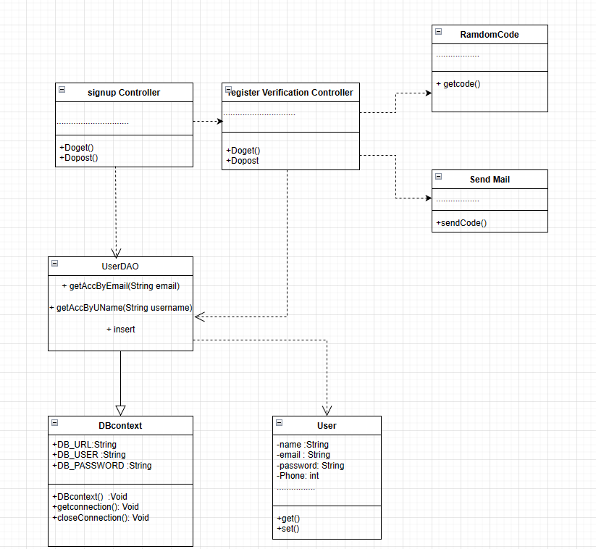

b. Class Specifications

Signup Controller

No | Method | Description
01 | doGet() | The doGet method is typically used when the client wants to access a web page, get data from the server, or perform read-only operations.
02 | doPost() | The doPost method is usually used when the client wants to send data to the server, like submitting a form or performing operations that can change the data.

register Verification Controller

No | Method | Description
01 | doGet() | The doGet method is typically used when the client wants to access a web page, get data from the server, or perform read-only operations.
02 | doPost() | The doPost method is usually used when the client wants to send data to the server, like submitting a form or performing operations that can change the data.

UserDAO

No | Method | Description
01 | getAccByEmail(String email) | + getAccByEmail(String email) is a method to check if the gmail entered by the user is duplicated with an gmail already in the data
02 | getAccByUName(String username) | + getAccByEmail(String email) is a method to check whether the user account name entered is the same as the account name already in the data.
03 | insert | + insert is the method that will create an account, and information for the user into the database.

randomCode class

No | Method | Description
01 | getCode() | at this function will auto random output a code with 5 numbers

sendmail class

No | Method | Description
01 | sendCode() | in this function will receive the email of the subscriber and the code that the machine automatically random . The code will then be sent to the user's email

c. Sequence Diagram(s)
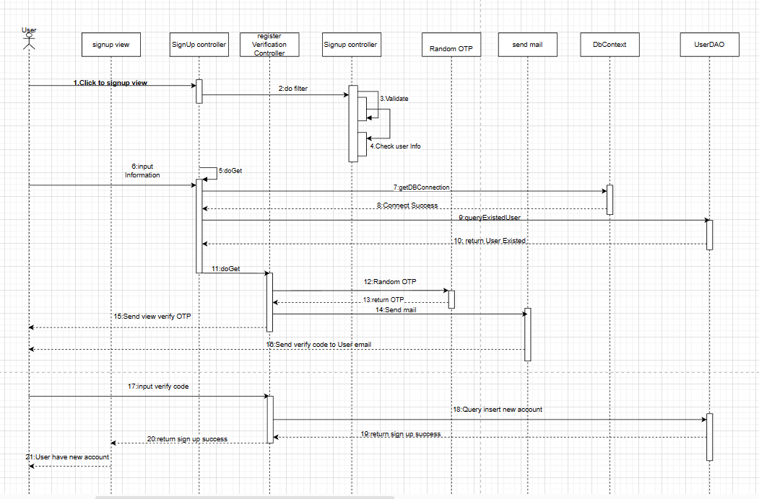
d. Database Queries
1:"SELECT * FROM swp391_group5.user where username =? ;"
2: "SELECT * FROM swp391_group5.user where email = ? "
3: INSERT INTO `swp391_group5`.`user` (`username`, `password`, `gender`, `full_name`, `date_of_birth`, `email`, `address`, `phone`, `role`, `user_status`) VALUES (?,?, ?, ?, ?, ?, ?, ?, ?, ?)";

3. View CV Mentor

a. Class Diagram

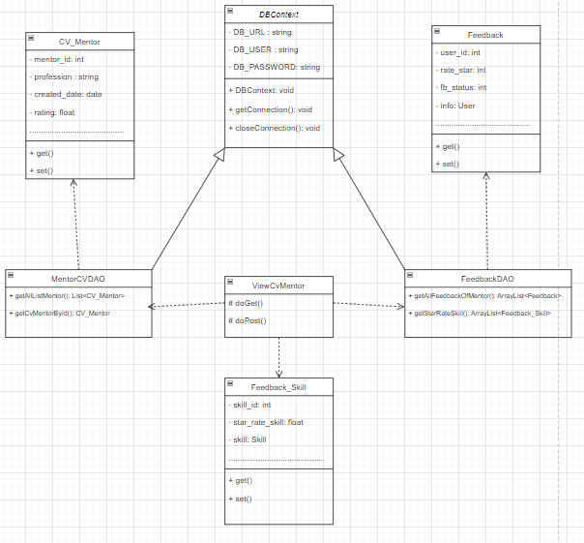

b. Class Specifications

ViewCvMentor Class

No | Method | Description
01 | doGet() | The doGet method is typically used when the client wants to access a web page, get data from the server, or perform read-only operations.
02 | doPost() | The doPost method is usually used when the client wants to send data to the server, like submitting a form or performing operations that can change the data.

MentorCVDAO Class

No | Method | Description
01 | getCvMentorById(String mentor_id) | This function takes out the information in Mentor's CV based on mentor_ID transmitted, the information taken includes the basic information and information related to Mentor's specialty.
02 | getAllListMentor() | This function takes out information about the CV of the mentors

FeedbackDAO Class

No | Method | Description
01 | getAllFeedbackOfMentor(int mentor_id) | This function takes out the feedback that Mentee has evaluated for a mentor based on mentor_ID. The information removed includes the number of stars and comments.
02 | getStarRateSkill() | This function takes out the skills that Mentor has been evaluated by Mentee.

c. Sequence Diagram(s)

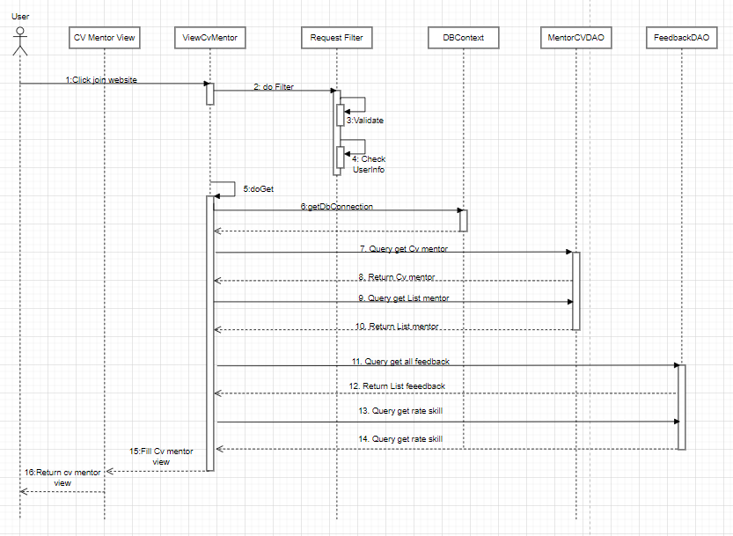

d. Database Queries
1: “select mentor_id ,full_name, avatar, email, username, phone, profession, profession_introduction,service_description, achievements,achievements_des, language from user join cv_of_mentor on user_id = mentor_id where mentor_id = ?”;
2: “select mentor_id ,email,full_name, avatar, profession, profession_introduction,service_description, achievements from user inner join cv_of_mentor on user_id = mentor_id”;
3: “SELECT email,full_name, avatar, feedback.user_id, mentor_id, rate_start, feedback_comment, feedback.create_date, fb_status FROM user join feedback on feedback.user_id = user.user_id where mentor_id = ?;”
4: “SELECT feedback_skill.skill_id, skill.skill_name, COUNT(*) AS skill_count, SUM(feedback_skill.rate_skill) AS total_rate_skill, ROUND(SUM(feedback_skill.rate_skill) / COUNT(*), 1) AS avg_rate_skill FROM swp391_group5.feedback_skill JOIN swp391_group5.skill ON feedback_skill.skill_id = skill.skill_id WHERE feedback_skill.mentor_id = ? GROUP BY feedback_skill.skill_id, skill.skill_name;”

4. Reset Password

a. Class Diagram
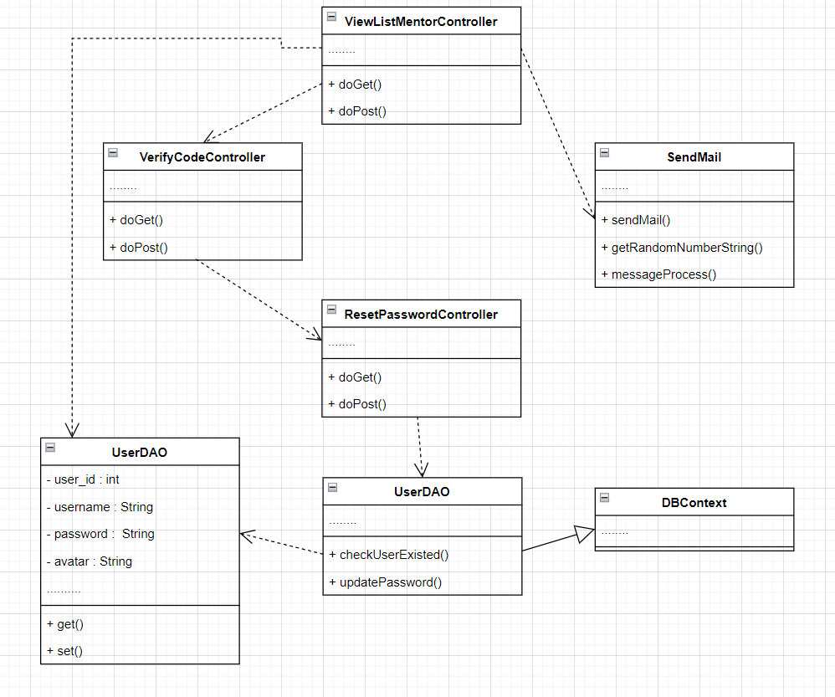

b. Class Specifications

ForgetPasswordController Class

No | Method | Description
01 | doGet() | The doGet method is typically used when the client wants to access a web page, get data from the server, or perform read-only operations.
02 | doPost() | The doPost method is usually used when the client wants to send data to the server, like submitting a form or performing operations that can change the data.

SendMailController Class

No | Method | Description
01 | doGet() | The doGet method is typically used when the client wants to access a web page, get data from the server, or perform read-only operations.
02 | doPost() | The doPost method is usually used when the client wants to send data to the server, like submitting a form or performing operations that can change the data.

VerifyCodeController Class

No | Method | Description
01 | doGet() | The doGet method is typically used when the client wants to access a web page, get data from the server, or perform read-only operations.
02 | doPost() | The doPost method is usually used when the client wants to send data to the server, like submitting a form or performing operations that can change the data.

ChangePassController Class

No | Method | Description
01 | doGet() | The doGet method is typically used when the client wants to access a web page, get data from the server, or perform read-only operations.
02 | doPost() | The doPost method is usually used when the client wants to send data to the server, like submitting a form or performing operations that can change the data.

UserDao Class

No | Method | Description
01 | checkUserExisted() | The checkUserExisted() method helps to check if an account exists in the database with the username as entered, the method returns a User object.
02 | updatePassword() | The updatePassword() method helps to update the new password of the forgotten account to the database

c. Sequence Diagram(s)
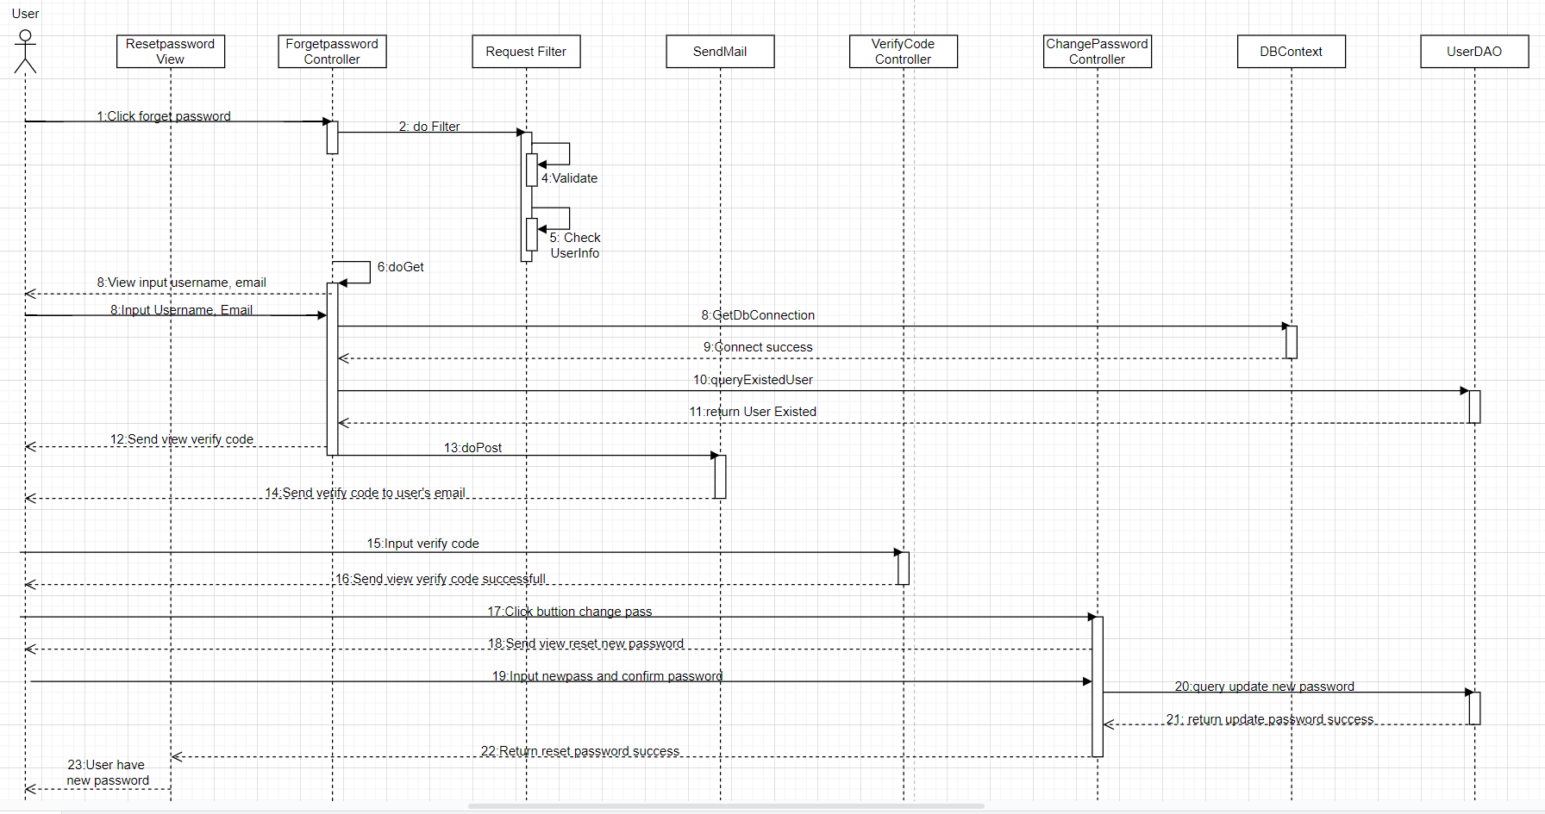

d. Database Queries
1: SELECT * FROM swp391_group5.user where username = ? and user_status = 1
2: UPDATE user SET `password` = ? WHERE `username` = ?

5. Update User Profile

a. Class Diagram

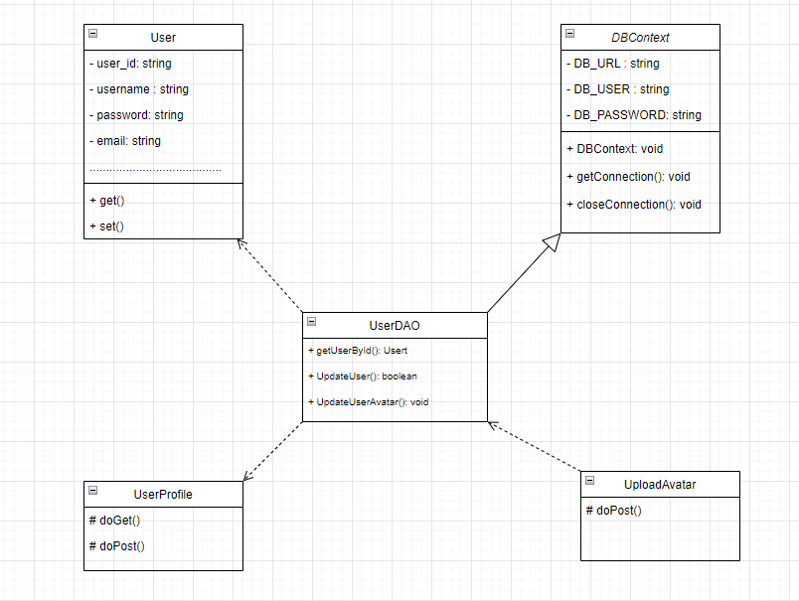

b. Class Specifications

UserProfile Class

No | Method | Description
01 | doGet() | The doGet method is typically used when the client wants to access a web page, get data from the server, or perform read-only operations.
02 | doPost() | The doPost method is usually used when the client wants to send data to the server, like submitting a form or performing operations that can change the data.

UploadAvatar Class

No | Method | Description
01 | doPost() | The doPost method is usually used when the client wants to send data to the server, like submitting a form or performing operations that can change the data.

UserDAO Class

No | Method | Description
01 | getUserById(int id) | This function takes the information of the user in the login session to display for the user.
02 | UpdateUser() | This function will get the user information to update.
03 | UpdateUserAvatar() | This function will update the link of the user avatar into the database.

c. Sequence Diagram(s)
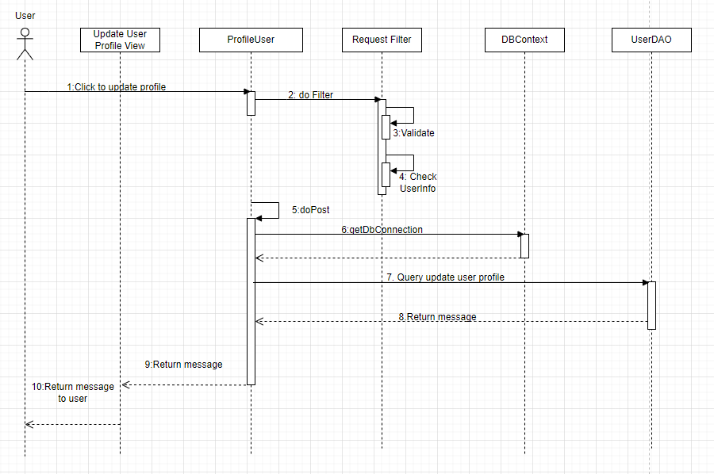

d. Database Queries
1: “SELECT username, gender, avatar, full_name, date_of_birth, email, address, phone FROM swp391_group5.user where user_id = ?”;
2: “UPDATE User SET gender = ?, full_name = ?, date_of_birth = ?, email = ?, address = ?, phone = ? WHERE user_id = ?;”
3: “UPDATE User SET avatar = ? WHERE user_id = ?”;

6. View All Skill

a. Class Diagram
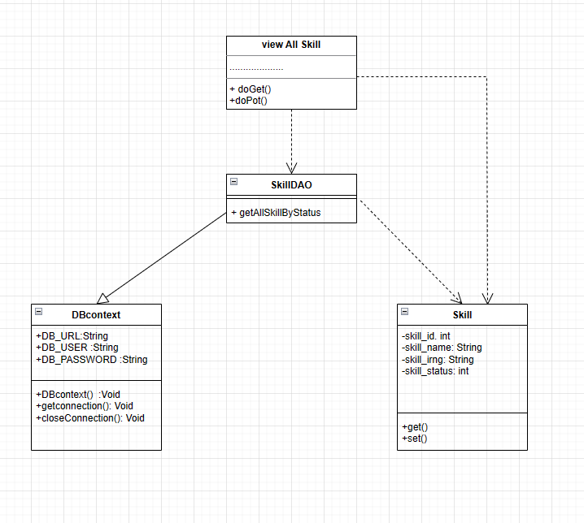

b. Class Specifications

ViewCvMentor Class

No | Method | Description
01 | doGet() | The doGet method is typically used when the client wants to access a web page, get data from the server, or perform read-only operations.
02 | doPost() | The doPost method is usually used when the client wants to send data to the server, like submitting a form or performing operations that can change the data.

SkillDAO class

No | Method | Description
01 | + getAllSkillByStatus() | This function gives the skills that mentee can learn

c. Sequence Diagram(s)
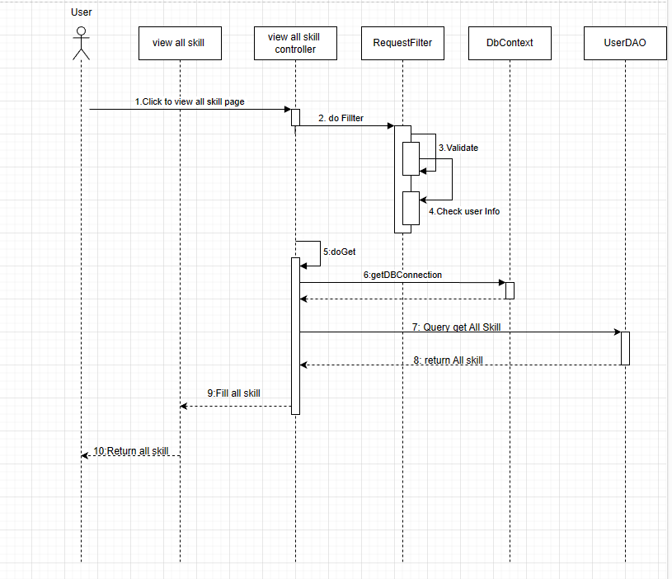
d. Database Queries
1: SELECT * FROM swp391_group5.skill WHERE skill_status = 1 ORDER BY skill_name;

7. Sign In

a.Class Diagram

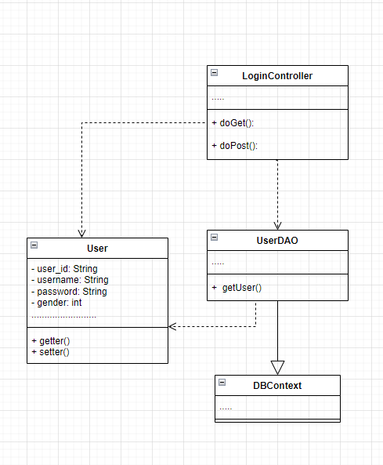

b. Class Specifications

Login Controller Class
No | Method | Description
01 | doGet() | The doGet method is typically used when the client wants to access a web page, get data from the server, or perform read-only operations.
02 | doPost() | The doPost method is usually used when the client wants to send data to the server, like submitting a form or performing operations that can change the data.

UserDAO Class

No | Method | Description
01 | getLogin() | The Login method is a method that receives data from the user and compares it with a list of users containing information about the user, such as password, account ....

c. Sequence Diagram(s)
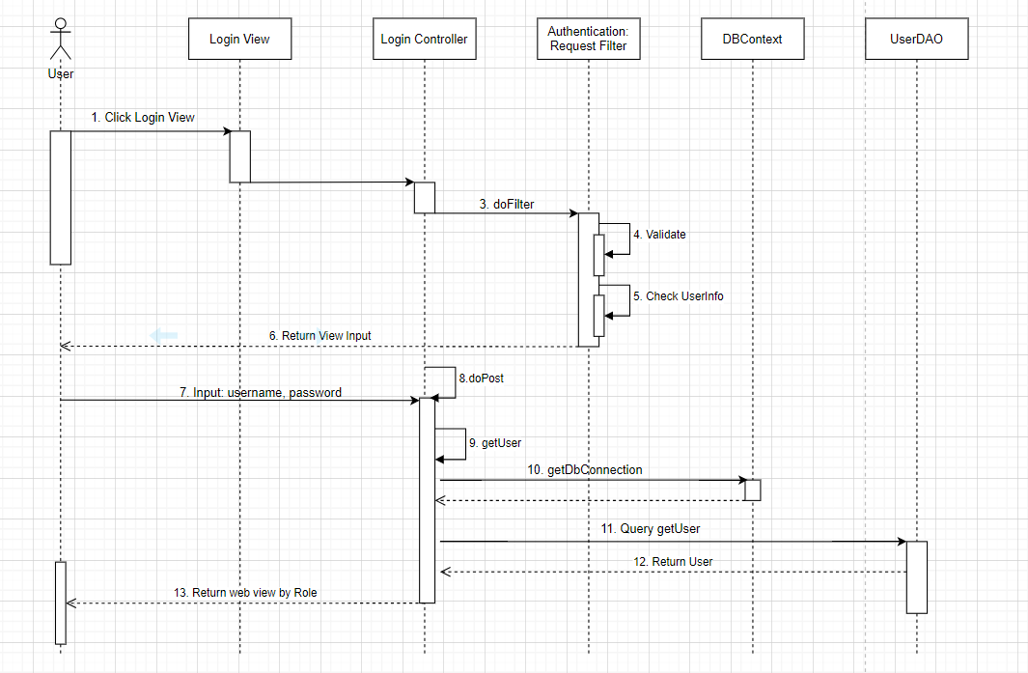

d. Database Queries
1: select * from user where username = ? and password = ?

8. List Mentor Suggestion

a. Class Diagram

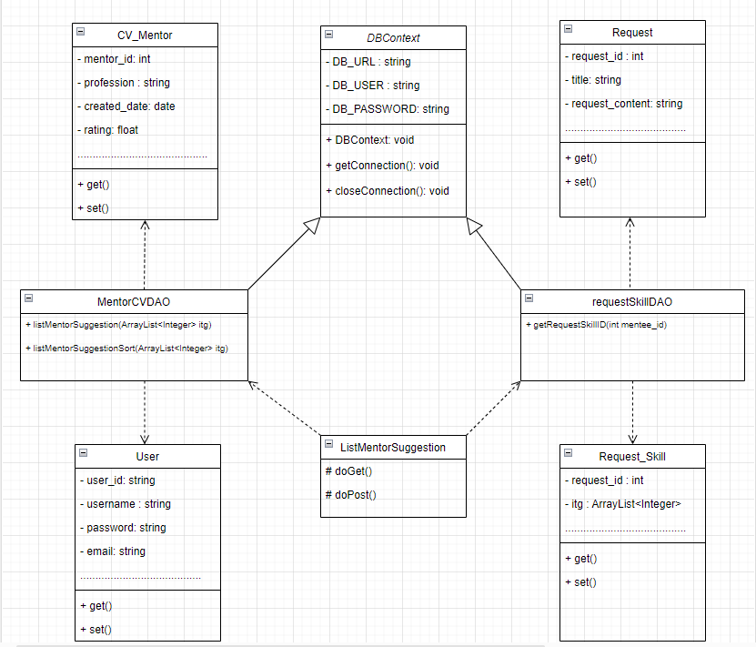

b. Class Specifications

ListMentorSuggestion Class

No | Method | Description
01 | doGet() | The doGet method is typically used when the client wants to access a web page, get data from the server, or perform read-only operations.
02 | doPost() | The doPost method is usually used when the client wants to send data to the server, like submitting a form or performing operations that can change the data.

MentorCVDAO Class

No | Method | Description
01 | listMentorSuggestion() | This function will take out the information of Mentor proposed to Mentee.
02 | listMentorSuggestionSort() | This function will take out the information of the Mentor proposed for mentee and arrange the number of stars.

requestSkillDAO Class

No | Method | Description
01 | getRequestSkillID() | This function will take out the skills that Mentee has requested.

c. Sequence Diagram(s)

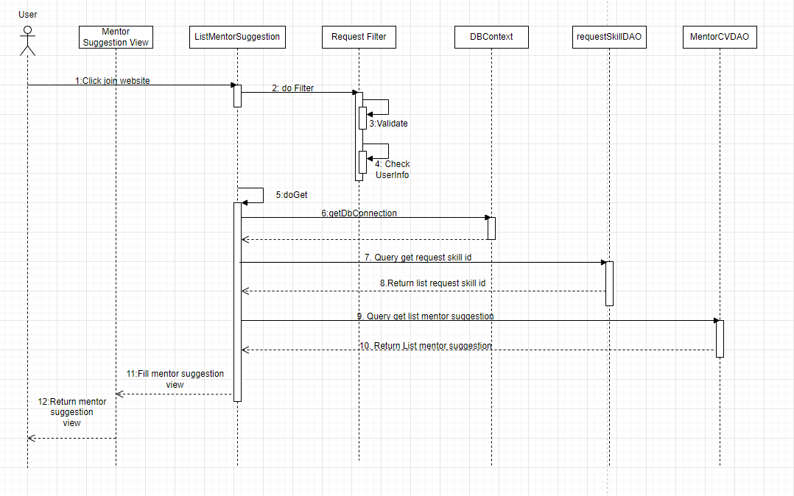

d. Database Queries

1: "SELECT cv_of_mentor.mentor_id, username,avatar, full_name, email, phone, cv_of_mentor.profession, GROUP_CONCAT(DISTINCT cv_skill.skill_id) AS skill_ids FROM swp391_group5.user JOIN swp391_group5.cv_of_mentor ON user.user_id = cv_of_mentor.mentor_id JOIN swp391_group5.cv_skill ON cv_of_mentor.mentor_id = cv_skill.mentor_id WHERE cv_skill.skill_id IN (" + String.join(",", Collections.nCopies(itg.size(), "?")) + ") GROUP BY cv_of_mentor.mentor_id, username,avatar, full_name, email, phone, cv_of_mentor.profession;";
2: "SELECT COUNT(request_id) AS count FROM swp391_group5.request WHERE mentor_id = ?"
3: "SELECT (SELECT SUM(rate_start) FROM swp391_group5.feedback WHERE mentor_id = ?) AS totalStar,(SELECT COUNT(rate_start) FROM swp391_group5.feedback WHERE mentor_id = ?) AS numberStar, ROUND((SELECT SUM(rate_start) FROM swp391_group5.feedback WHERE mentor_id = ?) / (SELECT COUNT(rate_start) FROM swp391_group5.feedback WHERE mentor_id = ?), 1) AS rating
4: SELECT distinct request_skill.skill_id FROM swp391_group5.request join swp391_group5.request_skill on request.request_id = request_skill.request_id where mentee_id = ?;
5: SELECT cv_of_mentor.mentor_id, username, avatar, full_name, email, phone, cv_of_mentor.profession,
GROUP_CONCAT(DISTINCT cv_skill.skill_id) AS skill_ids,
ROUND((SELECT SUM(rate_start) FROM swp391_group5.feedback WHERE mentor_id = cv_of_mentor.mentor_id) /
(SELECT COUNT(rate_start) FROM swp391_group5.feedback WHERE mentor_id = cv_of_mentor.mentor_id), 1) AS rating
FROM swp391_group5.user
JOIN swp391_group5.cv_of_mentor ON user.user_id = cv_of_mentor.mentor_id
JOIN swp391_group5.cv_skill ON cv_of_mentor.mentor_id = cv_skill.mentor_id
WHERE cv_skill.skill_id IN (2,3,4,5,6)
GROUP BY cv_of_mentor.mentor_id, avatar, email, phone, cv_of_mentor.profession
ORDER BY rating asc;

9. Create Request Mentee

a. Class Diagram
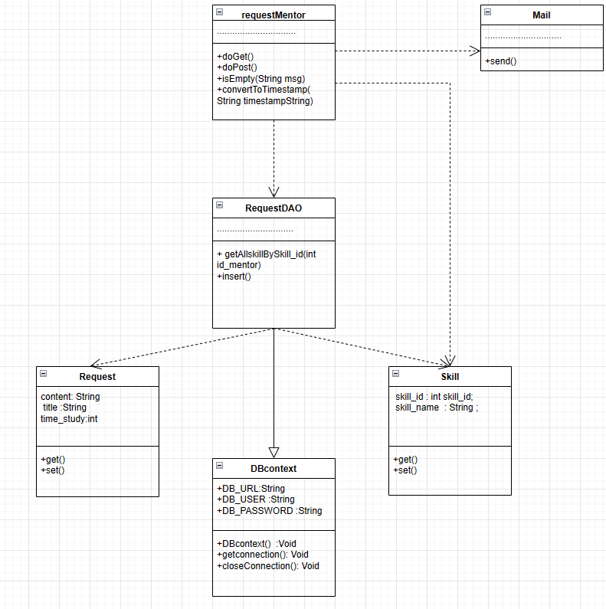

b. Class Specifications

ListMentorSuggestion Class

No | Method | Description
01 | doGet() | The doGet method is typically used when the client wants to access a web page, get data from the server, or perform read-only operations.
02 | doPost() | The doPost method is usually used when the client wants to send data to the server, like submitting a form or performing operations that can change the data.
03 | isEmpty(String msg) | At this function, it will check whether the information entered by the user is blank
04 | convertToTimestamp(String timestampString) | This function converts the user input time values from string to standard time

Mail class

No | Method | Description
01 | send() | at this function will send all the information that the user submits the request to the mentor

RequestDAO class
No | Method | Description
01 | getAllskillBySkill_id(int id_mentor) | This function will list the instructor's skills for the mentee to choose
02 | insert() | This function will transfer the information that the user sends to the mentor into the database

c. Sequence Diagram(s)
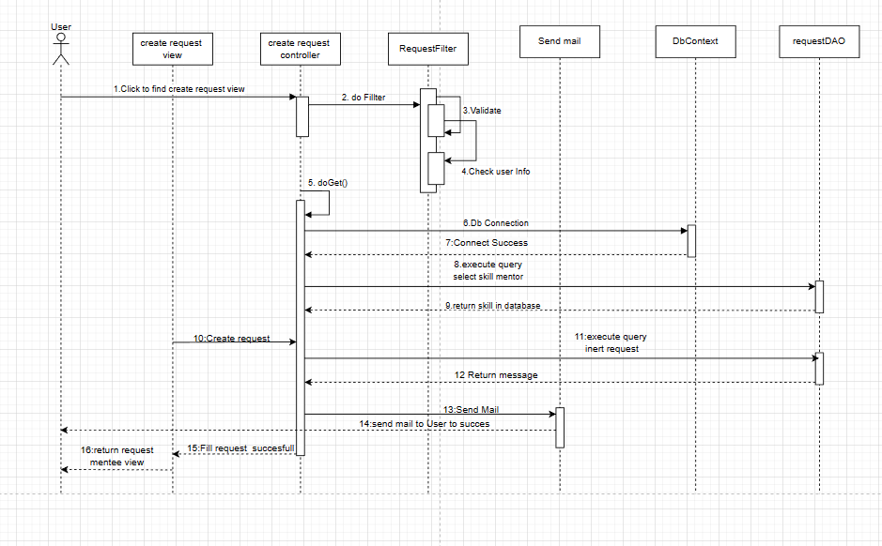

d. Database Queries
1: "SELECT cv_skill.mentor_id,cv_skill.skill_id,skill.skill_name,skill.skill_status\n"
+ "FROM swp391_group5.cv_skill\n"
+ "JOIN skill ON cv_skill.skill_id = skill.skill_id where skill.skill_status =1 and cv_skill.mentor_id?;"
2:"INSERT INTO `swp391_group5`.`request` ( `mentor_id`, `mentee_id`, "
+ "`title`, `request_content`, `time_study`, `time_begin`, `created_date`, `finish_date`, `request_status`)"
+ " VALUES ( ?, ?, ?, ?, ?, ?, ?, ?, ?)"
3: "INSERT INTO `swp391_group5`.`request_skill`\n"
+ "(`skill_id`,\n"
+ "`request_id`)\n"
+ "VALUES\n"
+ "(?,\n"
+ "?);"

10. List all mentor and search

a. Class Diagram
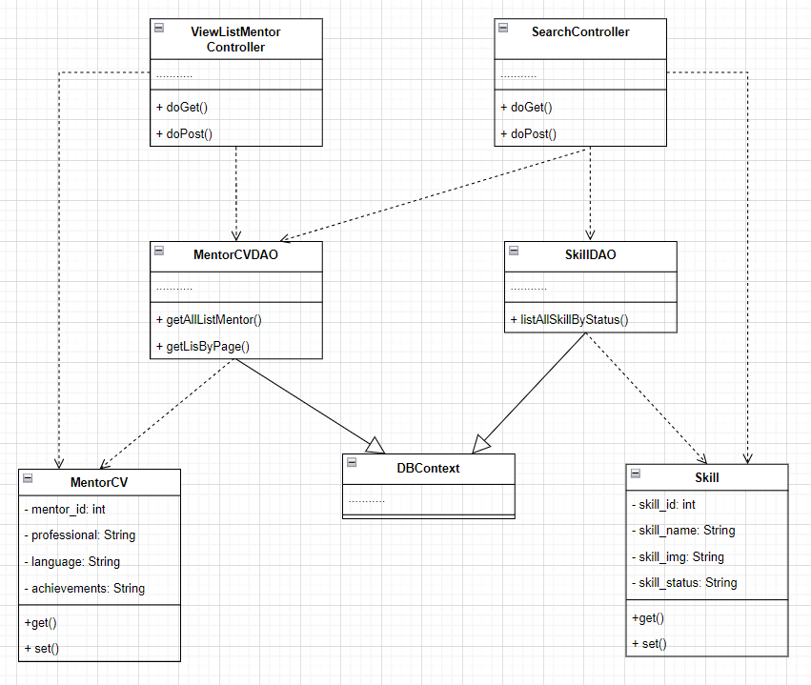

b. Class Specifications

ViewListMentorController Class
No | Method | Description
01 | doGet() | The doGet method is typically used when the client wants to access a web page, get data from the server, or perform read-only operations.
02 | doPost() | The doPost method is usually used when the client wants to send data to the server, like submitting a form or performing operations that can change the data.

SearchController Class
No | Method | Description
01 | doGet() | The doGet method is typically used when the client wants to access a web page, get data from the server, or perform read-only operations.
02 | doPost() | The doPost method is usually used when the client wants to send data to the server, like submitting a form or performing operations that can change the data.

MentorCVDAO Class
No | Method | Description
01 | getListAllMentor() | The method getAllListMentor() helps get the List() containing all the mentors with cv in the system, which can receive requests from the mentee. The method returns List<CVMentor>
02 | getListByPage() | The getListByPage() method helps to retrieve the List() containing all the mentors with cv in the system, paginated by the number of mentors in a page.

SkillDAO Class
No | Method | Description
01 | getSkillByStatus() | The getSkillByStatus() method helps to get the List() containing all the skills with active status in the system

c. Sequence Diagram(s)

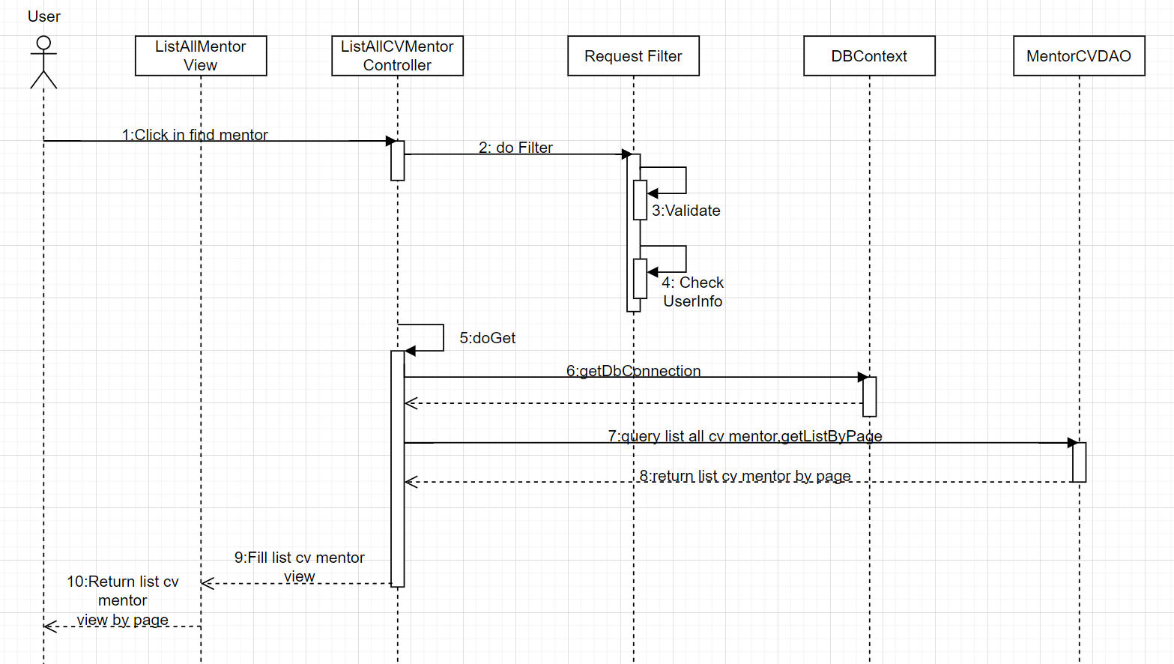

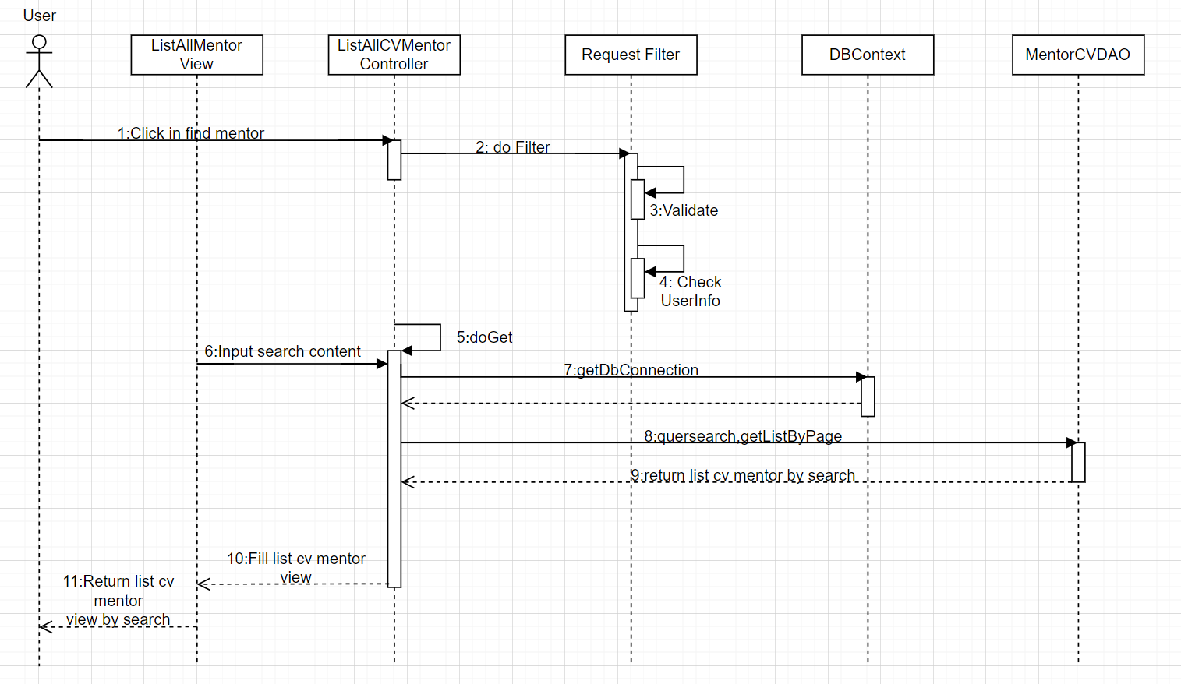

d. Database Queries
1.SELECT * FROM swp391_group5.skill where skill_status = 1
2.SELECT mentor_id ,email,full_name, avatar, profession,
profession_introduction,service_description, achievements
from user inner join cv_of_mentor
on user_id = mentor_id
3.select mentor_id ,email,full_name, avatar, profession, profession_introduction,service_description, achievements
from user inner join cv_of_mentor on user_id = mentor_id where 1=1
and full_name like '%" + keyword + "%'
and profession like '%" + professional + "%'
and service_description like '%" + service + "%'
and achievements like '%" + achievements + "%' ";

11. View list of skills

a. Class Diagram
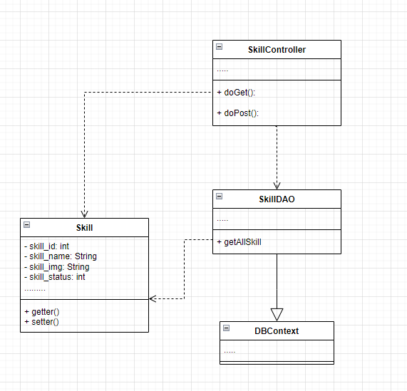

b. Class Specifications

Skill Controller Class
No | Method | Description
01 | doGet() | The doGet method is typically used when the client wants to access a web page, get data from the server, or perform read-only operations.
02 | doPost() | The doPost method is usually used when the client wants to send data to the server, like submitting a form or performing operations that can change the data.

SkillDAO Class

No | Method | Description
01 | getAllSkill() | The getAllSkill method is a method to get data from the database of all skills and store it in the Skill model

c. Sequence Diagram(s)
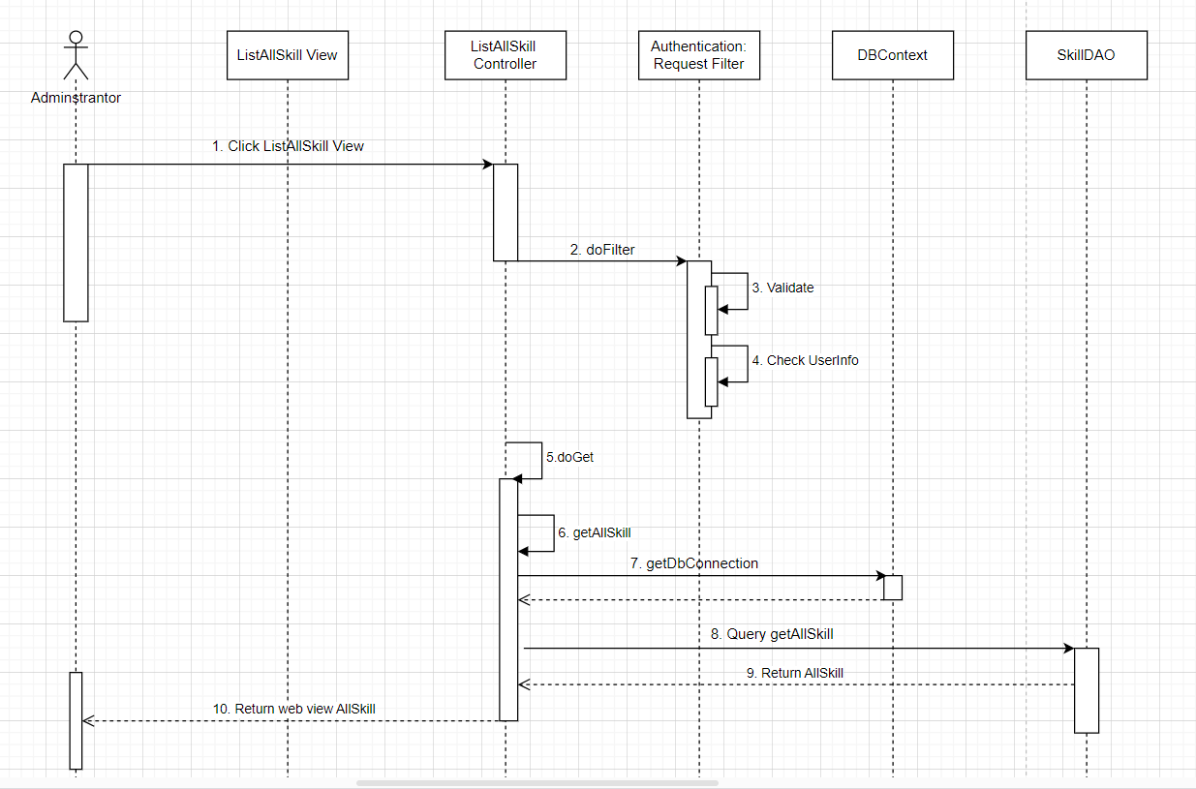

d. Database Queries
- SELECT * FROM swp391_group5.skill

12. Create CV of Mentor

a. Class Diagram
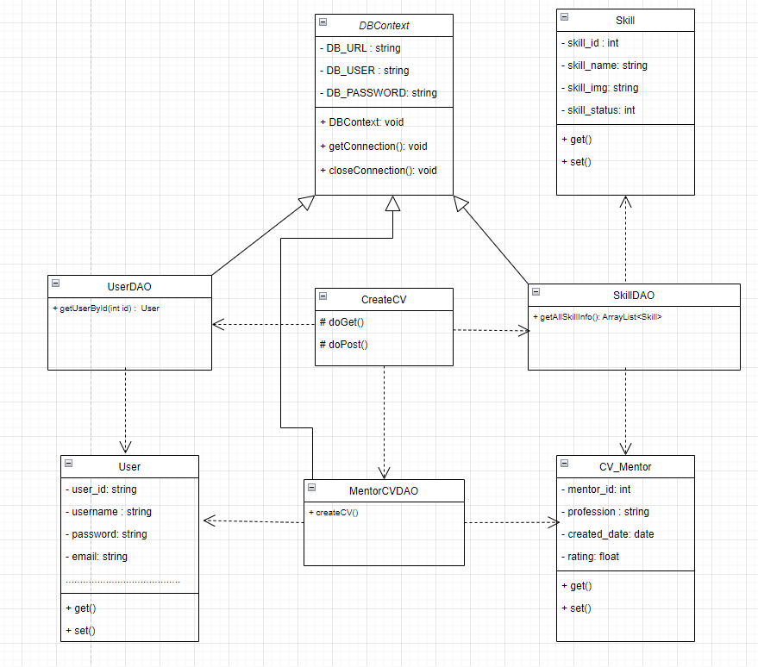

b. Class Specifications

CreateCV
No | Method | Description
01 | doGet() | The doGet method is typically used when the client wants to access a web page, get data from the server, or perform read-only operations.
02 | doPost() | The doPost method is usually used when the client wants to send data to the server, like submitting a form or performing operations that can change the data.

UserDAO Class

No | Method | Description
01 | getUserById(int id) | This function takes the information of the user in the login session to display for the user.

SkillDAO Class

No | Method | Description
01 | getAllSkillInfo() | This function takes out the information of the skills that the system has.

MentorCVDAO Class

No | Method | Description
01 | createCV() | This function will insert information about the CV that Mentor has entered into the database.

c. Sequence Diagram(s)

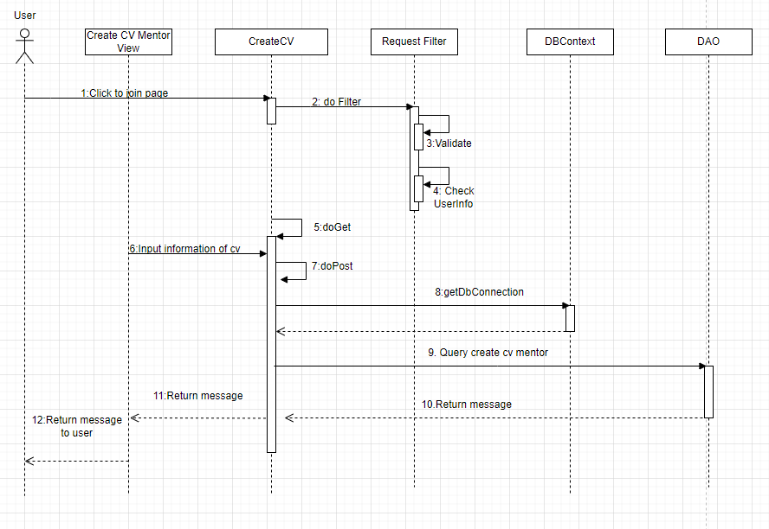

d. Database Queries

1: "SELECT * FROM swp391_group5.skill”;
2: "SELECT username, gender, avatar, full_name, date_of_birth, email, address, phone FROM swp391_group5.user where user_id = ?"
3: "UPDATE `swp391_group5`.`user` SET `gender` = ?, `full_name` = ?, `date_of_birth` = ?, `address` = ? WHERE `user_id` = ?;
4: INSERT INTO swp391_group5.`cv_of_mentor` (mentor_id, profession, profession_introduction, service_description, achievements, achievements_des, language) VALUES (?,?,?,?,?,?,?);
5: INSERT INTO `swp391_group5`.`cv_skill` (`mentor_id`, `skill_id`) VALUES (?,?)

13. View List Mentor

a. Class Diagram
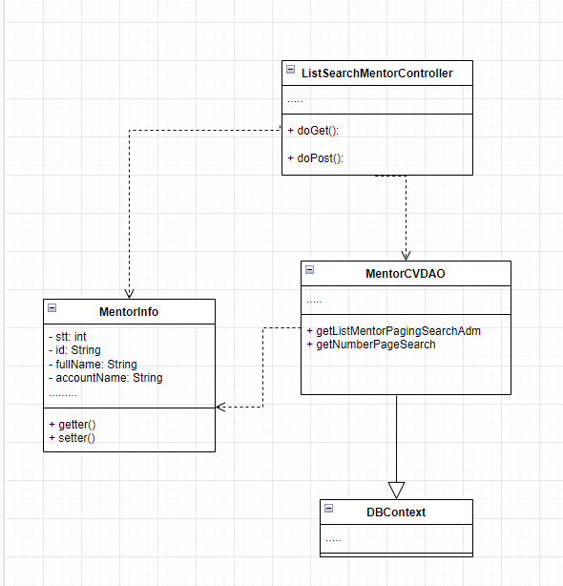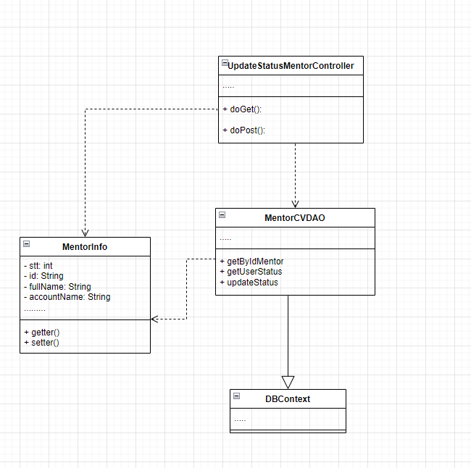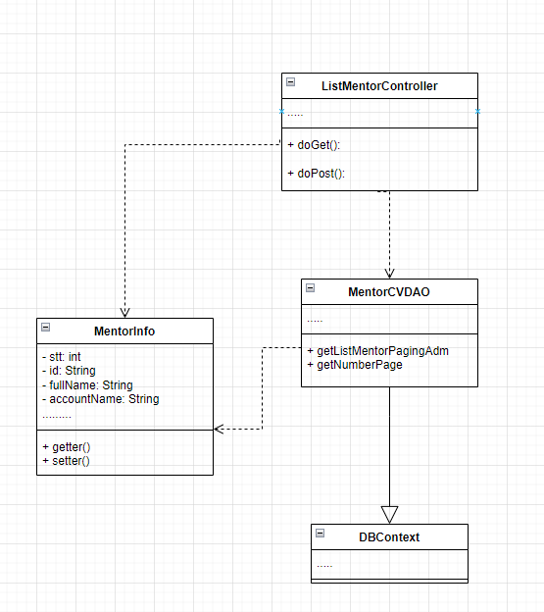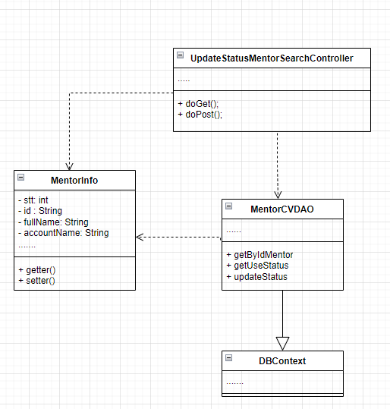

b. Class Specifications

ListMentorControl Class
No | Method | Description
01 | doGet() | The doGet method is typically used when the client wants to access a web page, get data from the server, or perform read-only operations.
02 | doPost() | The doPost method is usually used when the client wants to send data to the server, like submitting a form or performing operations that can change the data.
03 | GetListMentorPagingAdm() | Get the number of mentors according to a pre-distributed page on the total record

SearchControl Class
No | Method | Description
01 | GetListMentorPagingSearchAdm() | Get the number of mentors in the search page according to a pre-divided page on the total record. And the search results are in the database

UpdateStatusMentor Class

No | Method | Description
01 | GetByIdMentor() | Get the mentor's information in the database by that mentor's id
02 | updateStatus() | Mentor's update by id and updated value in the database

UpdateStatusMentorSearch Class

No | Method | Description
01 | GetByIdMentor() | Get the mentor's information in the database by that mentor's id
02 | updateStatus() | Mentor's update by id and updated value in the database

c. Sequence Diagram(s)
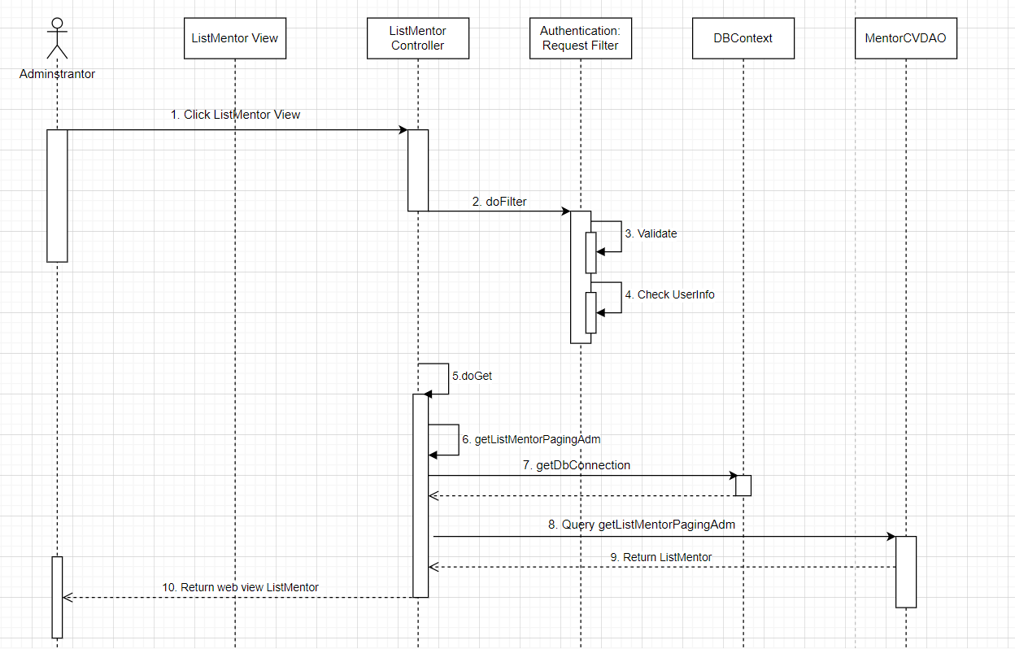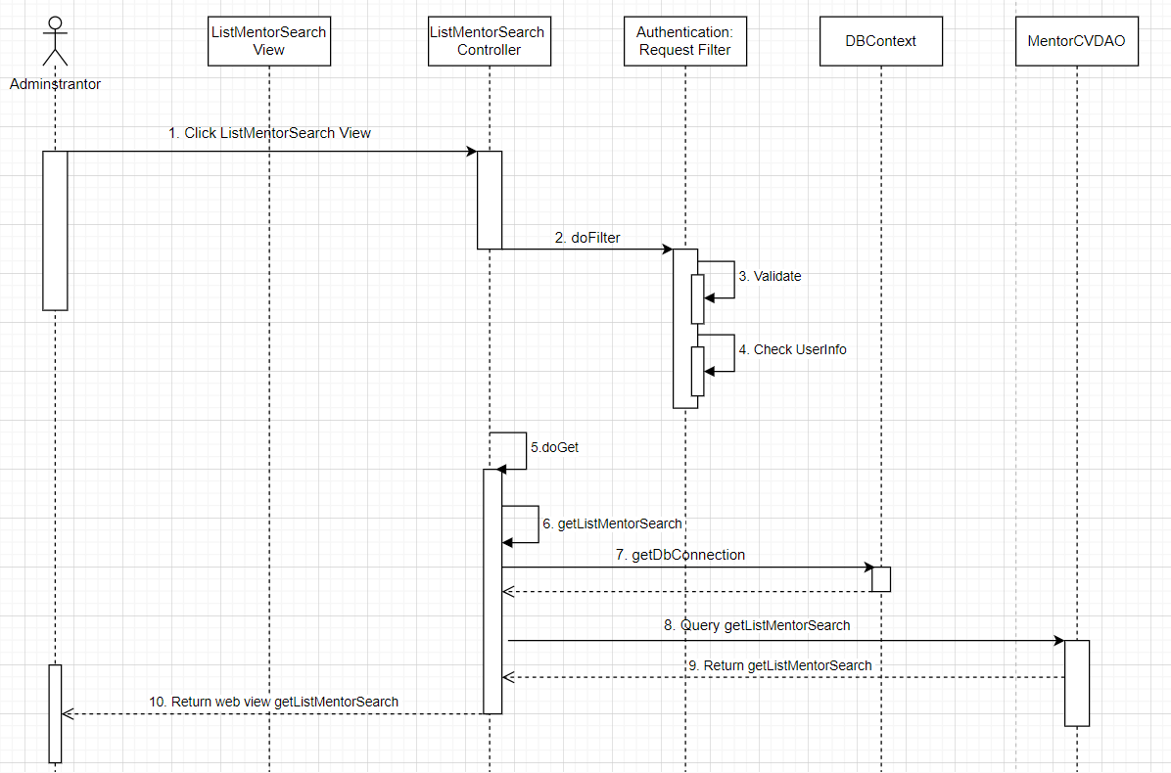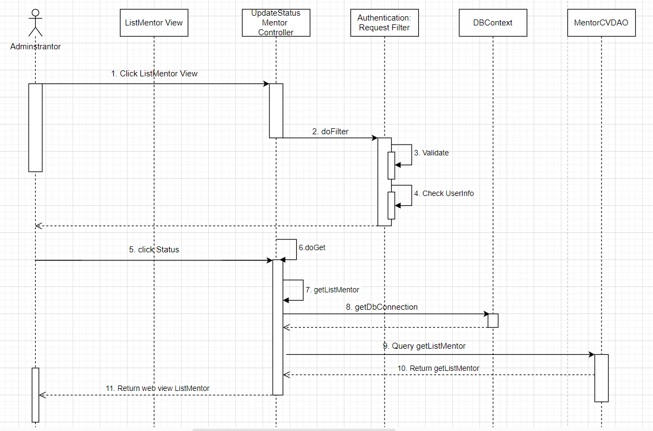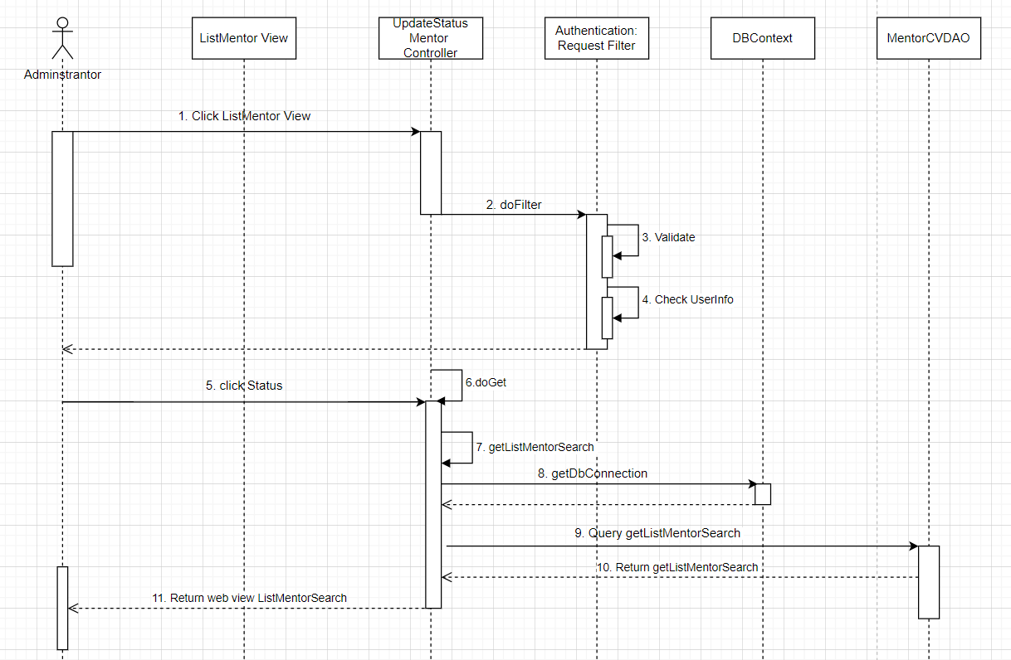

d. Database Queries
- SELECT ROW_NUMBER() OVER (ORDER BY cv_of_mentor.mentor_id) AS STT,
user.user_id AS ID,
user.full_name AS `Full name`,
user.username AS `Account name`,
cv_of_mentor.profession AS `Occupation`,
COUNT(CASE WHEN request.request_status IN (1, 2, 4) THEN 1 ELSE NULL END) AS `Number of currently`,
CONCAT(ROUND((COUNT(CASE WHEN request.request_status = 4 THEN 1 ELSE NULL END) / COUNT(CASE WHEN request.request_status IN (1, 2, 4) THEN 1 ELSE NULL END)) * 100), '%') AS `Percentage completed`,
ROUND(AVG(feedback.rate_start), 1) AS `Average star rating`,
CASE WHEN user.user_status = 1 THEN 1 ELSE 0 END AS `Active status of the advisor`
FROM swp391_group5.user
JOIN cv_of_mentor ON user.user_id = cv_of_mentor.mentor_id
LEFT JOIN request ON user.user_id = request.mentor_id
LEFT JOIN feedback ON user.user_id = feedback.mentor_id
WHERE user.role = 2 and user.full_name like '%j%'
GROUP BY user.user_id
LIMIT 10 OFFSET 0
- Select count(*) from swp391_group5.user where user.role = 2
- Select count(*) from swp391_group5.user where user.role = 2 and user.full_name like ?
- SELECT * FROM swp391_group5.user where user_id = ?"
- Update swp391_group5.user SET user_status = ? where user_id = ?
6. SELECT
ROW_NUMBER() OVER (ORDER BY cv_of_mentor.mentor_id) AS STT,
user.user_id AS ID,
user.full_name AS `Full name`,
user.username AS `Account name`,
cv_of_mentor.profession AS `Occupation`,
COUNT(CASE WHEN request.request_status IN (1, 2, 4) THEN 1 ELSE NULL END) AS `Number of currently`,CONCAT(ROUND((COUNT(CASE WHEN request.request_status = 4 THEN 1 ELSE NULL END) / COUNT(CASE WHEN request.request_status IN (1, 2, 4) THEN 1 ELSE NULL END)) * 100), '%') AS `Percentage completed`,
ROUND(AVG(feedback.rate_start), 1) AS `Average star rating`,
CASE WHEN user.user_status = 1 THEN 1 ELSE 0 END AS `Active status of the advisor`
FROM swp391_group5.user
JOIN cv_of_mentor ON user.user_id = cv_of_mentor.mentor_id
LEFT JOIN request ON user.user_id = request.mentor_id
LEFT JOIN feedback ON user.user_id = feedback.mentor_id
WHERE user.role = 2
GROUP BY user.user_id
LIMIT 10 OFFSET 0;

14. Update Request

a. Class Diagram
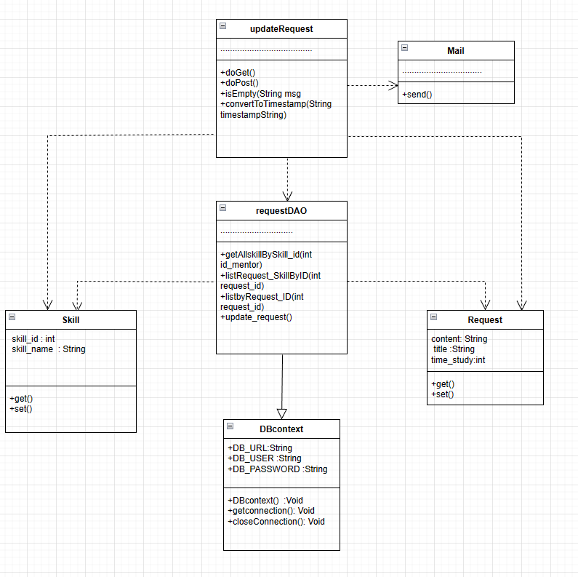

b. Class Specifications

updatateRequest Class

No | Method | Description
01 | doGet() | The doGet method is typically used when the client wants to access a web page, get data from the server, or perform read-only operations.
02 | doPost() | The doPost method is usually used when the client wants to send data to the server, like submitting a form or performing operations that can change the data.
03 | isEmpty(String msg) | At this function, it will check whether the information entered by the user is blank
04 | convertToTimestamp(String timestampString) | This function converts the user input time values from string to standard time

Mail class

No | Method | Description
01 | send() | at this function will send all the information that the user submits the request to the mentor

RequestDAO Class

No | Method | Description
01 | getAllskillBySkill_id(int id_mentor) | This function will list all the skills the mentor has chosen by the mentor
02 | listRequest_SkillByID(int request_id) | This function will get the skill selected by the user in the previous request
03 | +listbyRequest_ID(int request_id) | This function will retrieve the updateable information so that the user can edit

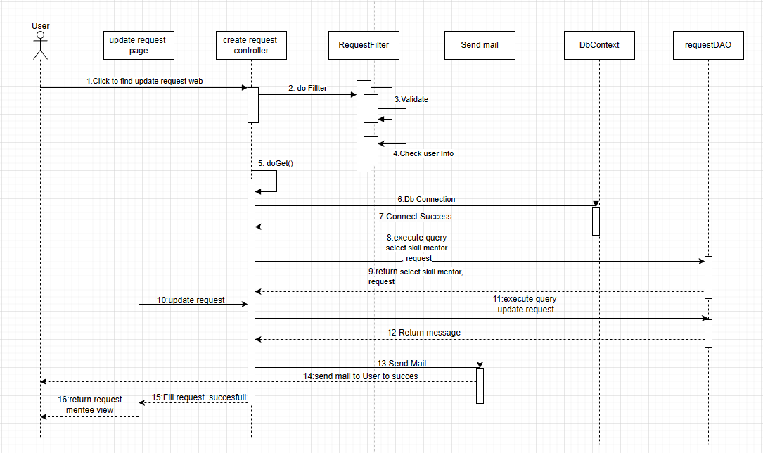

d. Database Query
1: "SELECT * FROM swp391_group5.request where request_id=?;"
2: "SELECT cv_skill.mentor_id,cv_skill.skill_id,skill.skill_name,skill.skill_status\n"
+ "FROM swp391_group5.cv_skill\n"
+ "JOIN skill ON cv_skill.skill_id = skill.skill_id where skill.skill_status =1 and cv_skill.mentor_id = ?;";

3:"SELECT request_skill.request_id,request_skill.skill_id,skill.skill_name "
+ "FROM swp391_group5.request_skill JOIN skill ON request_skill.skill_id = skill.skill_id "
+ "where request_id = ?;";

4:"UPDATE `swp391_group5`.`request` SET `title` = ?, `request_content` = ?, `time_study` = ?, "
+ "`time_begin` = ?, `created_date` = ?, `finish_date` = ? WHERE (`request_id` = ?);"

5:"DELETE FROM `swp391_group5`.`request_skill`\n"
+ "WHERE request_id = ? ;"

6:"INSERT INTO `swp391_group5`.`request_skill`\n"
+ "(`skill_id`,\n"
+ "`request_id`)\n"
+ "VALUES\n"
+ "(?,\n"
+ "?);"

15. User Authorization

a. Class Diagram (None)

b. Class Specifications (None)
c. Sequence Diagram(s) (None)

d. Database Queries (None)

16. Rate & comment mentor

a. Class Diagram

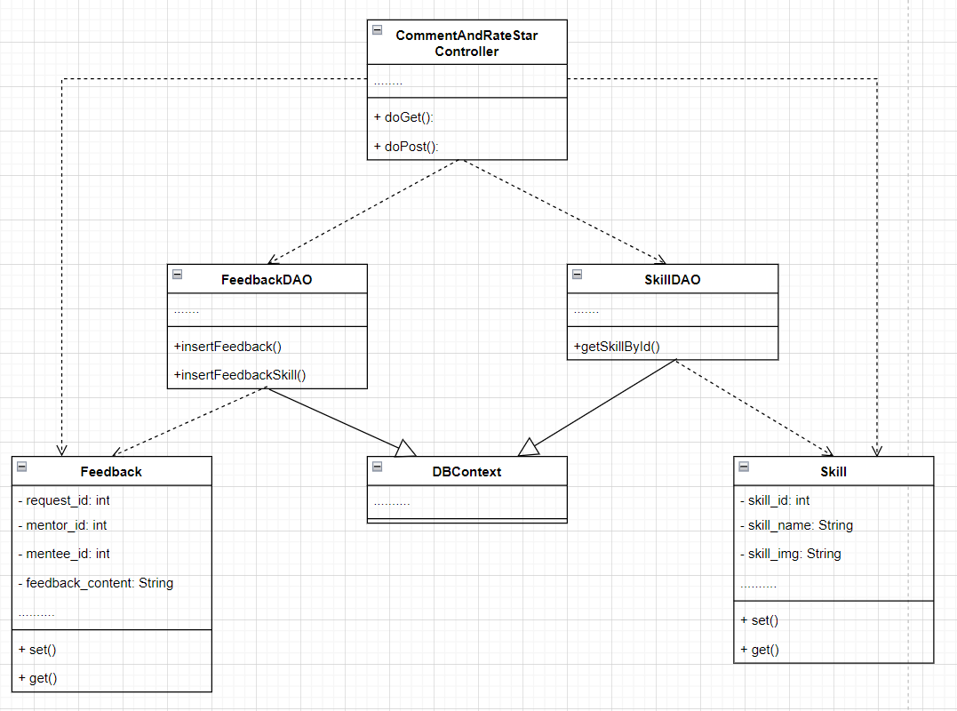

b. Class Specifications

CommentAndRateStartController Class
No | Method | Description
01 | doGet() | The doGet method is typically used when the client wants to access a web page, get data from the server, or perform read-only operations.
02 | doPost() | The doPost method is usually used when the client wants to send data to the server, like submitting a form or performing operations that can change the data.

FeedbackDAO Class
No | Method | Description
01 | insertFeedback() | The insertFeedback() method helps push the reviews from mentee to mentor to the database to store and view on the rating list.

c. Sequence Diagram(s)
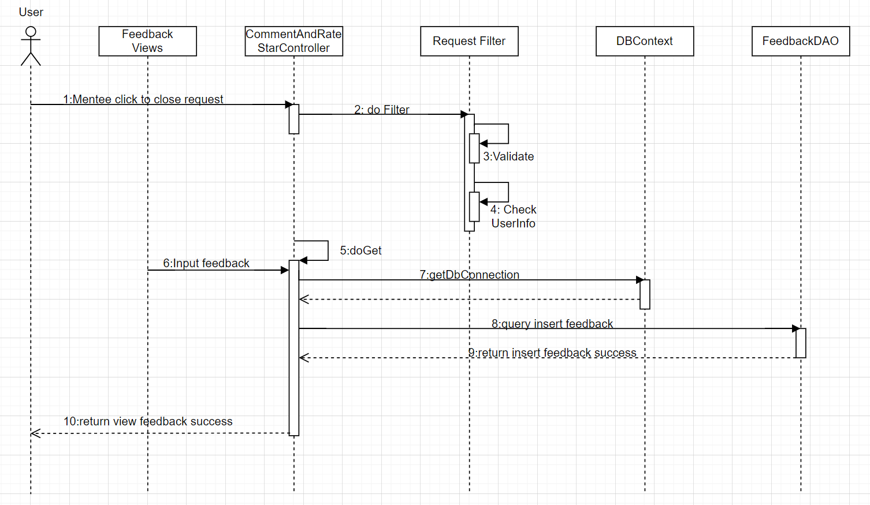

d. Database Queries
1.INSERT INTO `swp391_group5`.`feedback`
(`user_id`,
`mentor_id`,
`rate_start`,
`feedback_comment`,
`create_date`,
`fb_status`)
VALUES
(?,?,?,?,?,?);
2.INSERT INTO `swp391_group5`.`feedback_skill`
(`mentee_id`,
`mentor_id`,
`skill_id`,
`rate_skill`)
VALUES
(?,?,?,?);

17. Update Skill

a. Class Diagram
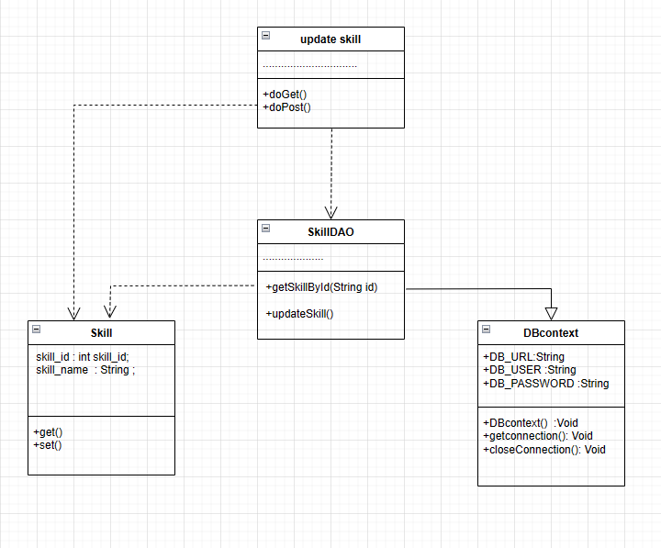

b. Class Specifications

Login Controller Class
No | Method | Description
01 | doGet() | The doGet method is typically used when the client wants to access a web page, get data from the server, or perform read-only operations.
02 | doPost() | The doPost method is usually used when the client wants to send data to the server, like submitting a form or performing operations that can change the data.

SkillDAO Class

No | Method | Description
01 | getSkillById(String id) | in this function will retrieve all the information of the skill that the user wants to update
02 | updateSkill() | in this function will scroll down all the information of the skill that the user wants to update

c. Sequence Diagram(s)
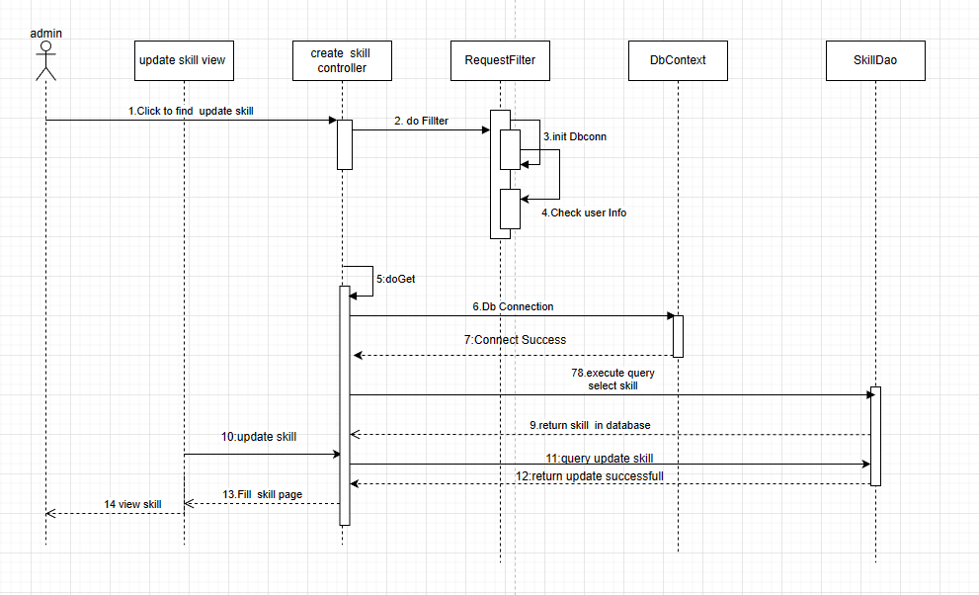
1:"select * from swp391_group5.skill where skill_id = ?"
2:"UPDATE swp391_group5.skill SET skill_name = ?, skill_img = ?, skill_status = ? WHERE skill_id = ?"

18. Statistic Request By Me

a. Class Diagram
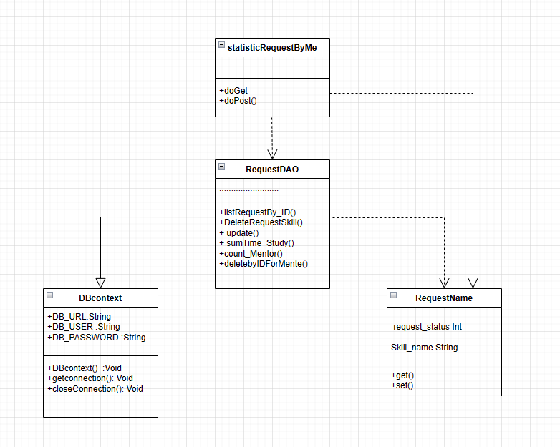

b. Class Specifications

Login Controller Class
No | Method | Description
01 | doGet() | The doGet method is typically used when the client wants to access a web page, get data from the server, or perform read-only operations.
02 | doPost() | The doPost method is usually used when the client wants to send data to the server, like submitting a form or performing operations that can change the data.

request DAO Class
No | Method | Description
01 | listRequestBy_id() | in this function will print all the requests that the user has created
02 | deleteBy_idid | in this function user will be able to delete request by id

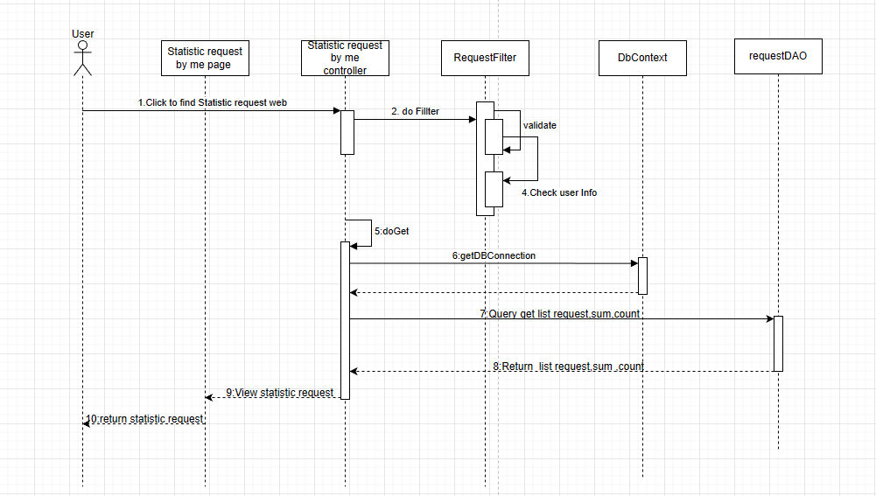

d. Database Queries

1: SELECT * FROM swp391_group5.request where mentee_id= " + mentee_id + ";"
2:UPDATE `swp391_group5`.`request` SET `request_status` = ? WHERE `request_id` = ?;
3: "delete from swp391_group5.request_skill where request_id = " + request_id + "";
4:SELECT SUM(time_study) As sum FROM swp391_group5.request where mentee_id=?;
5:SELECT COUNT(DISTINCT mentor_id) As count FROM swp391_group5.request where mentee_id=?;
6:DELETE FROM swp391_group5.`request` WHERE request_id = ?

19. View List Following Request

a. Class Diagram
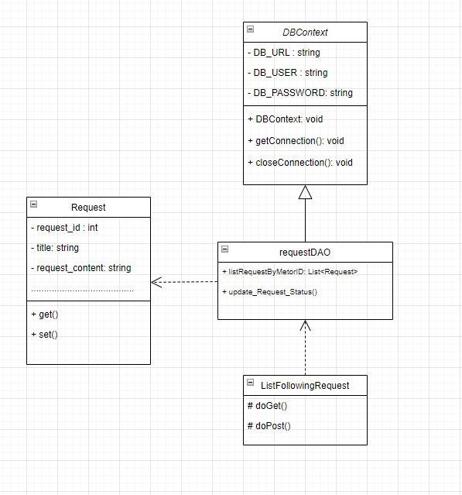

b. Class Specifications

List Following Request

No | Method | Description
01 | doGet() | The doGet method is typically used when the client wants to access a web page, get data from the server, or perform read-only operations.
02 | doPost() | The doPost method is usually used when the client wants to send data to the server, like submitting a form or performing operations that can change the data.

requestDAO Class

No | Method | Description
01 | listRequestByMetorID(String mentor_id) | This function takes out the requests that Mentor receives from Mentee
02 | update_Request_Status() | This function will update the status of the request based on the action of the mentor.

c. Sequence Diagram(s)
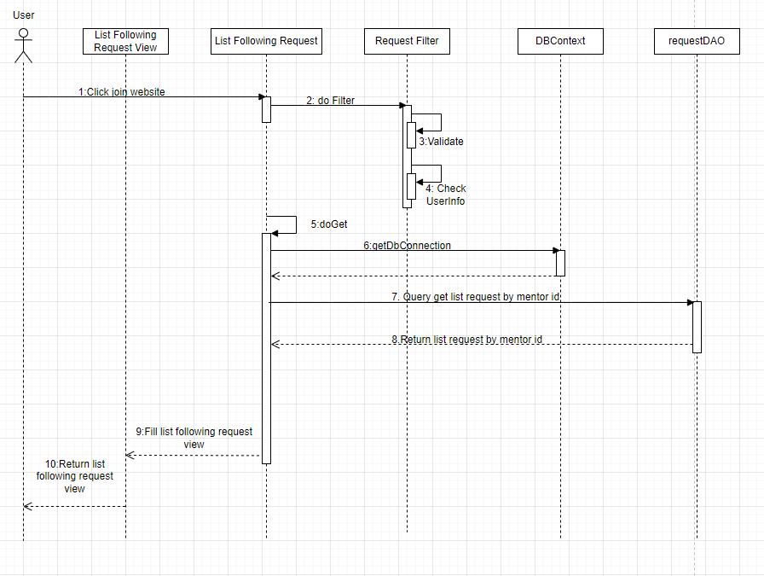

d. Database Queries
1: "SELECT * FROM swp391_group5.request where mentor_id = ? and request_status = 1 limit 10 offset ?;"
2:"select skill.skill_name from swp391_group5.request_skill join swp391_group5.skill on skill.skill_id = request_skill.skill_id where request_skill.request_id = ?;"
3: “UPDATE `swp391_group5`.`request` SET `request_status` = ? WHERE `request_id` = ?;”

20. View statistic request

a. Class Diagram
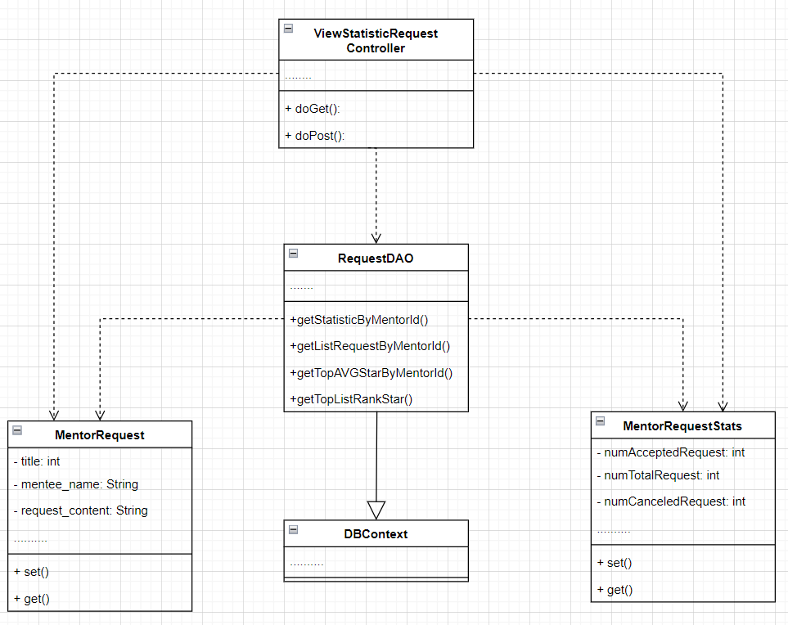

b. Class Specifications

ViewStatisticRequestController Class

No | Method | Description
01 | doGet() | The doGet method is typically used when the client wants to access a web page, get data from the server, or perform read-only operations.
02 | doPost() | The doPost method is usually used when the client wants to send data to the server, like submitting a form or performing operations that can change the data.

ViewStatisticRequestController Class

No | Method | Description
01 | getStatisticByMentorId() | The getStatisticByMentorId() method is the mentor_id access method to get the total number of requests, number of request accept, number of request cancel, percentage of request accept, percentage of request.
02 | getListRequestByMentorId() | The method getListRequestByMentorId() is the method that accesses the mentor_id to retrieve the List containing all the requests of the mentor containing that mentor_id.
03 | getTopRateAVGStarByMentorId() | The method getTopRateAVGStarByMentorId() is the method that passes in the mentor_id to get the avg star rank of that mentor
04 | getListTopRankStar() | The getListTopRankStar() method is the method to get the List ranked rank avg star from high to low

c. Sequence Diagram(s)
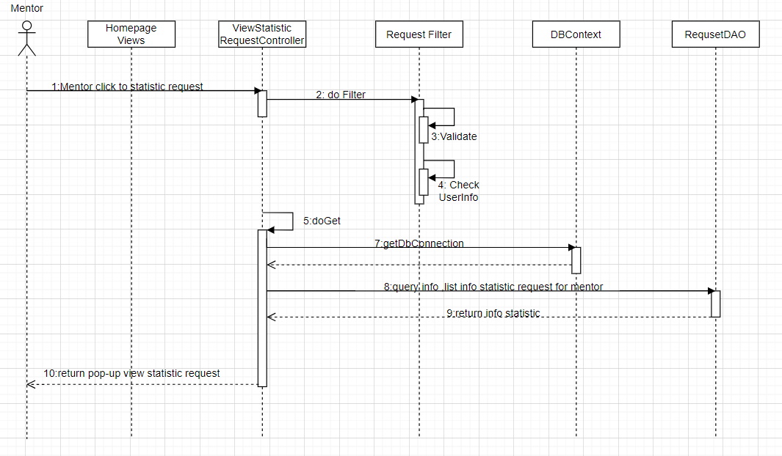

d. Database Queries
1.SELECT COUNT(CASE WHEN r.request_status IN (2, 4) THEN 1 END) AS num_accepted_requests,
COUNT(CASE WHEN r.request_status IN (1,2,3, 4) THEN 1 END) AS num_total_requests,
COUNT(CASE WHEN r.request_status = 3 THEN 1 END) AS num_canceled_requests,
CONCAT(ROUND(COUNT(CASE WHEN r.request_status = 3 THEN 1 END) * 100 / COUNT(CASE WHEN r.request_status IN (1,2,3,4) THEN 1 END), 2), '%') AS cancel_percentage,
CONCAT(ROUND(COUNT(CASE WHEN r.request_status = 4 THEN 1 END) * 100 / COUNT(CASE WHEN r.request_status IN (1,2,3,4) THEN 1 END), 2), '%') AS completed_percentage
FROM request r
LEFT JOIN feedback f ON r.mentee_id = f.user_id AND r.mentor_id = f.mentor_id
LEFT JOIN request_status rs ON r.request_status = rs.status_id
WHERE r.mentor_id = ?
2.SELECT ROW_NUMBER() OVER(ORDER BY r.created_date) AS STT,
u.full_name AS name_mentee, r.title,
r.request_content, r.created_date, r.finish_date, rs.status_name AS request_status
FROM request r
INNER JOIN user u ON r.mentee_id = u.user_id
INNER JOIN request_status rs ON r.request_status = rs.status_id
WHERE r.mentor_id = ?
ORDER BY r.created_date ASC
3.Select TOP from (SELECT
ROW_NUMBER() OVER (ORDER BY AVG(f.rate_start) DESC) AS TOP,
u.user_id,
CONCAT(u.full_name) AS name_mentor,
ROUND(AVG(f.rate_start),1) AS Rate_start
FROM user u
LEFT JOIN feedback f ON u.user_id = f.mentor_id
LEFT JOIN role r ON u.role = r.role_id
WHERE
r.role_id = 2
GROUP BY
u.user_id
ORDER BY
Rate_start DESC) as Toplist WHERE Toplist.user_id = ?
4.SELECT
ROW_NUMBER() OVER (ORDER BY AVG(f.rate_start) DESC) AS TOP,
u.user_id,
CONCAT(u.full_name) AS name_mentor,
ROUND(AVG(f.rate_start),1) AS Rate_start
FROM user u
LEFT JOIN feedback f ON u.user_id = f.mentor_id
LEFT JOIN role r ON u.role = r.role_id
WHERE
r.role_id = 2
GROUP BY
u.user_id
ORDER BY
Rate_start DESC

21. Change Password

a. Class Diagram
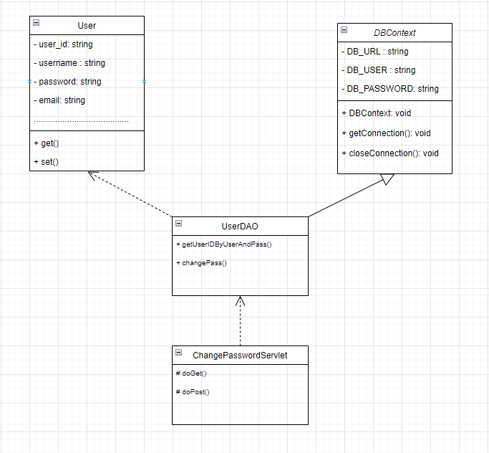

b. Class Specifications

ChangePasswordServlet Class

No | Method | Description
01 | doGet() | The doGet method is typically used when the client wants to access a web page, get data from the server, or perform read-only operations.
02 | doPost() | The doPost method is usually used when the client wants to send data to the server, like submitting a form or performing operations that can change the data.

UserDAO Class

No | Method | Description
01 | getUserIDByUserAndPass() | This function takes out the user's user_ID.
02 | changepass() | This function will change the password

c. Sequence Diagram(s)

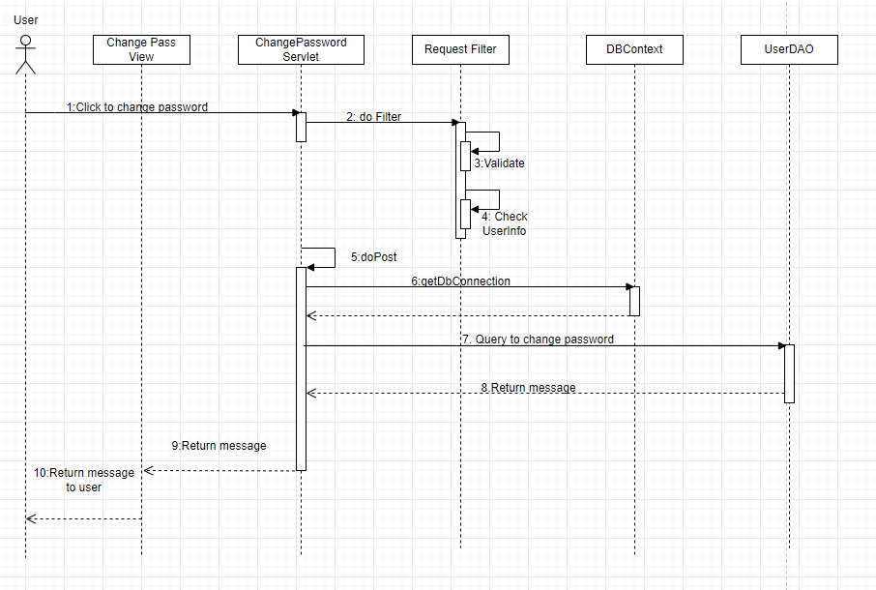

d. Database Queries
1: SELECT * FROM swp391_group5.user where username = ? and password = ?
2: UPDATE `swp391_group5`.`user` SET `password` = ? WHERE (`user_id` = ?)

22. Update CV of Mentor

a. Class Diagram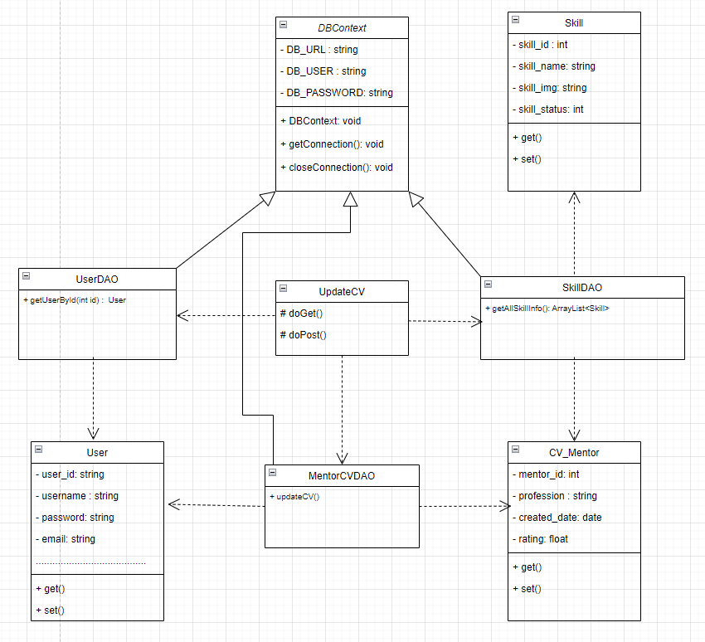

b. Class Specifications

UpdateCV
No | Method | Description
01 | doGet() | The doGet method is typically used when the client wants to access a web page, get data from the server, or perform read-only operations.
02 | doPost() | The doPost method is usually used when the client wants to send data to the server, like submitting a form or performing operations that can change the data.

UserDAO Class

No | Method | Description
01 | getUserById(int id) | This function takes the information of the user in the login session to display for the user.

SkillDAO Class

No | Method | Description
01 | getAllSkillInfo() | This function takes out the information of the skills that the system has.

MentorCVDAO Class

No | Method | Description
01 | updateCV() | This function will update information about the CV that Mentor has entered into the database.
02 | getInfoCvMentorById() | This function takes out the old information in Mentor's CV to be able to update.

c. Sequence Diagram(s)

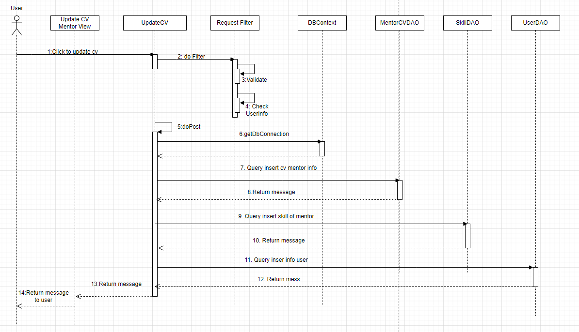

d. Database Queries
1: SELECT * FROM swp391_group5.skill
2. Select mentor_id ,username, gender, full_name, date_of_birth, email, address, profession, profession_introduction,service_description, "
achievements,achievements_des, language from user join cv_of_mentor on user_id = mentor_id where mentor_id = ?

3: UPDATE `swp391_group5`.`user` SET `gender` = ?, `full_name` = ?, `date_of_birth` = ?, `address` = ? WHERE `user_id` = ?;
4: UPDATE `swp391_group5`.`cv_of_mentor` SET `profession` = ?, `profession_introduction` = ?, `service_description` = ?, `achievements` = ?, `achievements_des` = ?, `language` = ? WHERE `mentor_id`= ?;
5.UPDATE `swp391_group5`.`cv_skill` SET `skill_id` = ? WHERE `mentor_id` = ?;

23. List Request By Me

a. Class Diagram
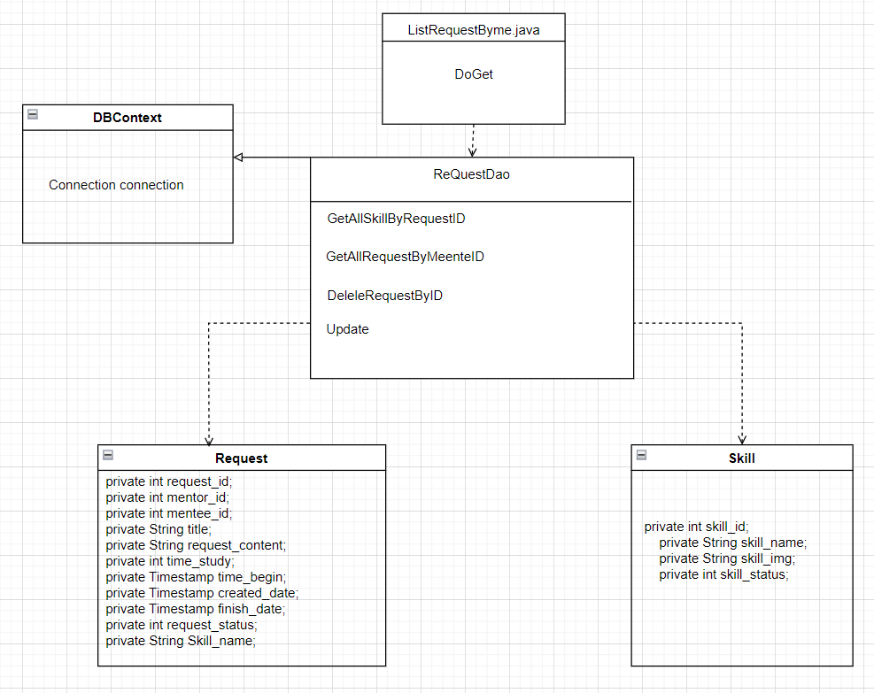

b. Class Specifications

ListRequestByMe Class
No | Method | Description
01 | doGet() | The doGet method is typically used when the client wants to access a web page, get data from the server, or perform read-only operations.

requestDAO Class

No | Method | Description
01 | GetAllSkillByRequestID() | This function takes out skill information about Mentee's request
02 | GetAllRequestByMenteeID() | Get all request by mentee id
03 | DeleteRequestByID() | Delete request By ID
04 | Update() | Update status for request

c. Sequence Diagram(s)

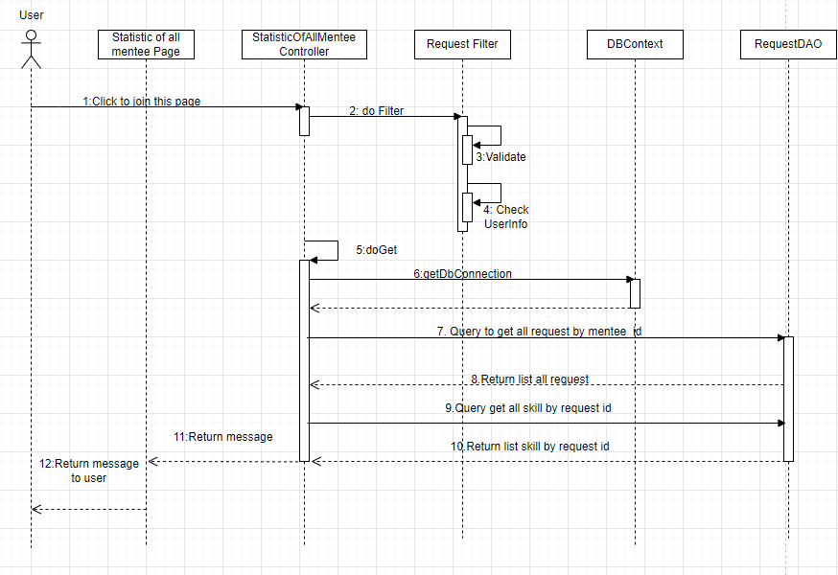

d. Database Queries

1: DELETE FROM swp391_group5.`request` WHERE request_id = ?
2: Delete from swp391_group5.request_skill where request_id = ?
3: UPDATE `swp391_group5`.`request` SET `request_status` = ? WHERE `request_id` = ?
4: SELECT TIMESTAMPADD(SQL_TSI_DAY, 2, '" + finish.toString() + "')
5. Select b.* from request_skill a join skill b on a.skill_id=b.skill_id where request_id = " +request_id +"

24. Create Skill

a. Class Diagram
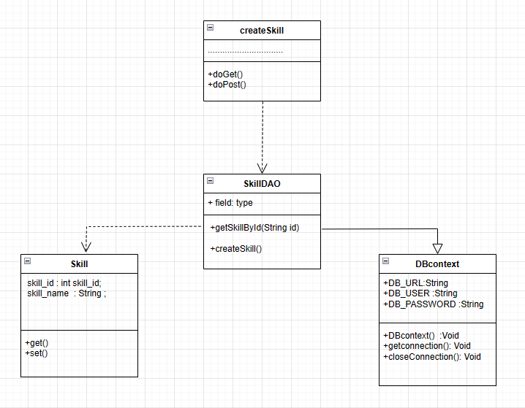

b. Class Specifications

CreateSkill Class
No | Method | Description
01 | doGet() | The doGet method is typically used when the client wants to access a web page, get data from the server, or perform read-only operations.
02 | doPost() | The doPost method is usually used when the client wants to send data to the server, like submitting a form or performing operations that can change the data.

SkillDAO Class

No | Method | Description
01 | getSkillById() | This function takes all the information of the skill.
02 | createSkill() | This function to create skill

c. Sequence Diagram(s)
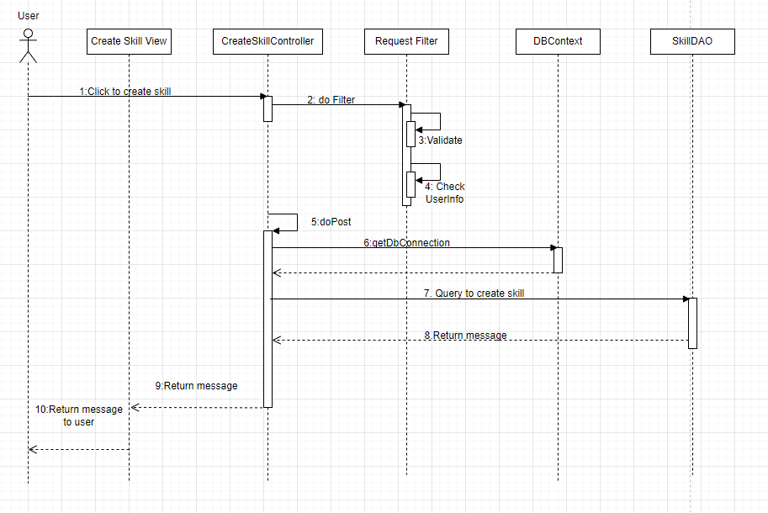

d. Database Queries

1: INSERT INTO swp391_group5.skill (`skill_name`, `skill_img`, `skill_status`) VALUES (?, ?, ?)

25. Statistics of all mentee

a. Class Diagram
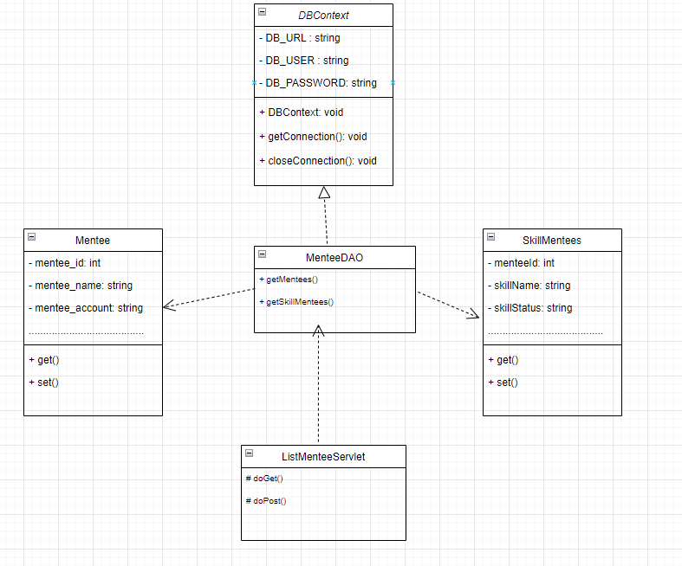

b. Class Specifications

ListMentee Servlet
No | Method | Description
01 | doGet() | The doGet method is typically used when the client wants to access a web page, get data from the server, or perform read-only operations.
02 | doPost() | The doPost method is usually used when the client wants to send data to the server, like submitting a form or performing operations that can change the data.

MenteeDAO Class

No | Method | Description
01 | getMentees() | This function takes the list of mentees, including the number of hours of class, full name, username, avatar ....
02 | getSkillMentees() | This function takes the list of skills that Mentee has asked for Mentor.

c. Sequence Diagram(s)

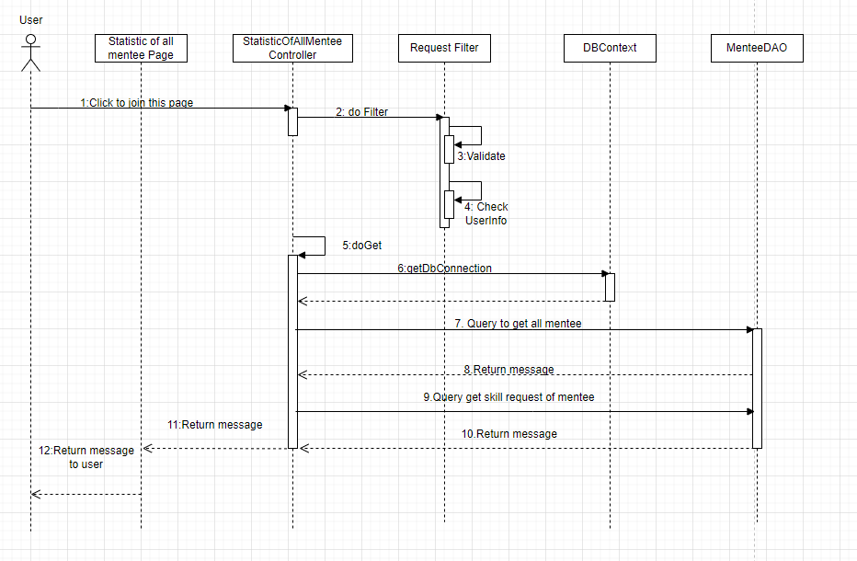

d. Database Queries

1. SELECT
user.user_id,
user.full_name,
user.username,
subquery.time_study,
COUNT(DISTINCT request_skill.skill_id) AS skill_count\n"
FROM
swp391_group5.`user`
JOIN swp391_group5.`request` ON user.user_id = request.mentee_id
LEFT JOIN
SELECT
request.mentee_id,
SUM(request.time_study) AS time_study
FROM
swp391_group5.`request`
GROUP BY
request.mentee_id
AS subquery ON request.mentee_id = subquery.mentee_id
LEFT JOIN swp391_group5.`request_skill` ON request.request_id = request_skill.request_id
GROUP BY
user.user_id,
user.full_name,
user.username,
subquery.time_study
ORDER BY
user.full_name
LIMIT 10 offset ?

